**Course Description**

It's time to push forward and develop your Python chops even further. There are tons of fantastic functions in Python and its library ecosystem. However, as a data scientist, you'll constantly need to write your own functions to solve problems that are dictated by your data. You will learn the art of function writing in this first Python Data Science Toolbox course.

You'll come out of this course being able to write your very own custom functions, complete with multiple parameters and multiple return values, along with default arguments and variable-length arguments. You'll gain insight into scoping in Python and be able to write lambda functions and handle errors in your function writing practice. And you'll wrap up each chapter by using your new skills to write functions that analyze Twitter DataFrames.

**1. Writing your own functions**

In this chapter, you'll learn how to write simple functions, as well as functions that accept multiple arguments and return multiple values. You'll also have the opportunity to apply these new skills to questions commonly encountered by data scientists.



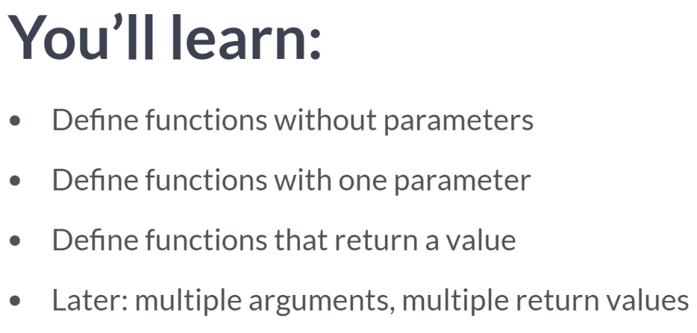  
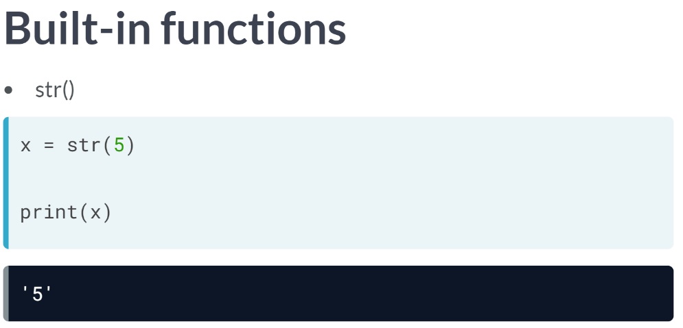  
***str()*** accepts an object such as a number and return a string object.  
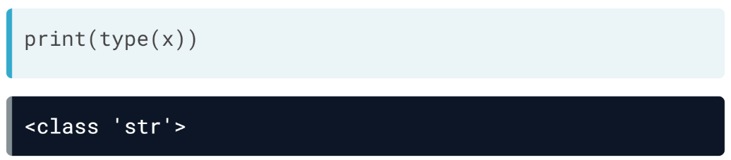  
You can assign a call to str to a variable to store its return value.

As a data scientist, we will need functions that have functionality specific to our needs. Fortunately, we can define our own functions in Python.

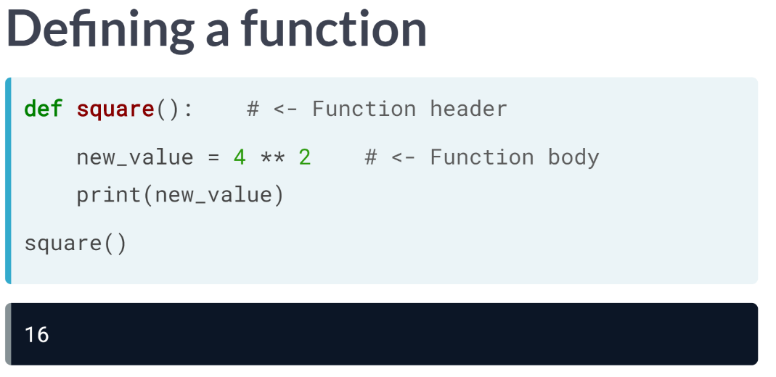  
We'll now see how to define functions via an example, a function that squares a number. The function name square will be perfect for this.

Look at the code above, right now, our square function doesn't have any parameters within the parentheses. We will add them later.

Now whenever this function is called, the code in the function body is run. In this case, *new_value* is assigned the value of 4 ** 2 and then printed out.

You can call the function as you do with pre-built functions: square. This value yields 16.

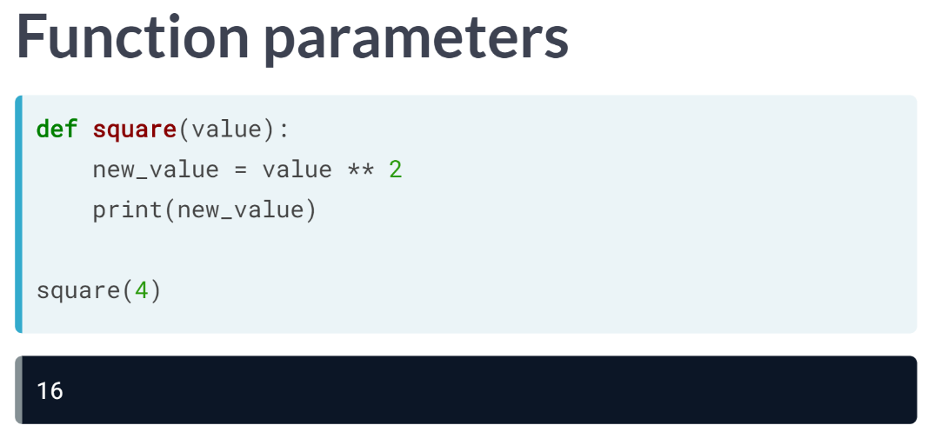  
What if you wanted to square any other number besides 4, though? To add that functionality, we add a parameter to the function definition in between the parentheses.

Here we have added a parameter value, and in the new function body, the variable new_value takes the square of value, which is then printed out.

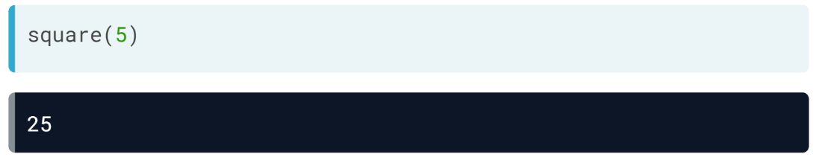  
We can now square any number that we pass to the function square as an argument.   
  
When you define a function, you write parameters in the function header. When you call a function, you pass arguments into the function.

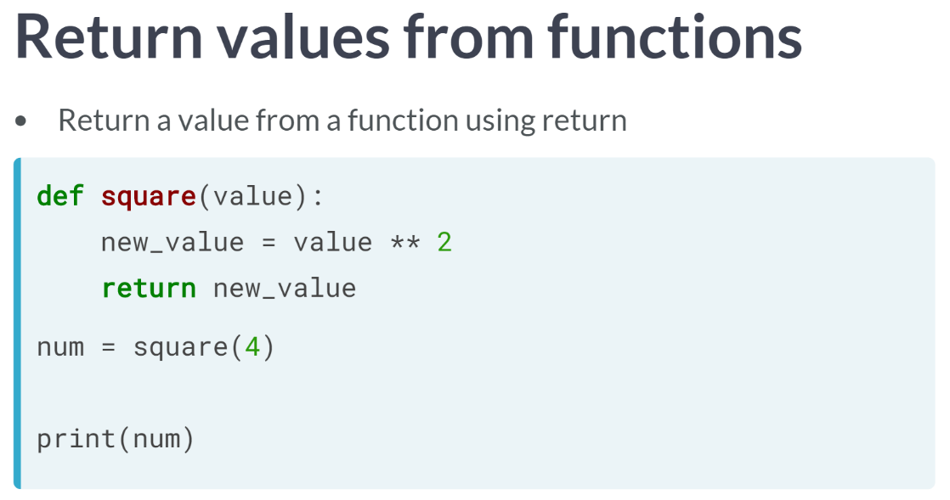  
The function square now accepts a single parameter and prints out its squared value. But what if we don't want to print out value directly but instead return the squared value and assign it to some variable?

You can have your function return the new value by adding the return keyword, followed by the value to return. Now we can assign to a variable num the result of the function call as we can see above.

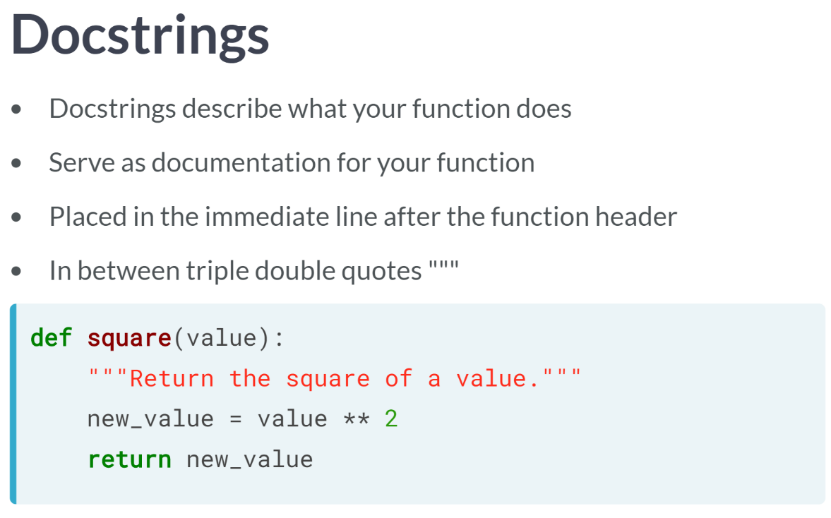  
docstrings is another essential aspect of writing function in Python. It is used to describe what the the function does, such as the computation it performs or its return value.

These descriptions serve as documentation for the function so that anyone who reads your function's docstring understands what your function does, without having to trace through all the code in the function definition.

It is placed in the immediate line after the function header and are placed in between triple quotation marks. An appropriate Docstring for this function square above is 'Returns the square of a value'.

# Strings in Python

In the video, you learned of another standard Python datatype, **strings**. Recall that these represent textual data. To assign the string 'DataCamp' to a variable company, you execute:

company = 'DataCamp'

You've also learned to use the operations + and * with strings. Unlike with numeric types such as ints and floats, the + operator concatenates strings together, while the * concatenates multiple copies of a string together. In this exercise, you will use the + and * operations on strings to answer the question below. Execute the following code in the shell:

object1 = "data" + "analysis" + "visualization"

object2 = 1 * 3

object3 = "1" * 3

What are the values in object1, object2, and object3, respectively?

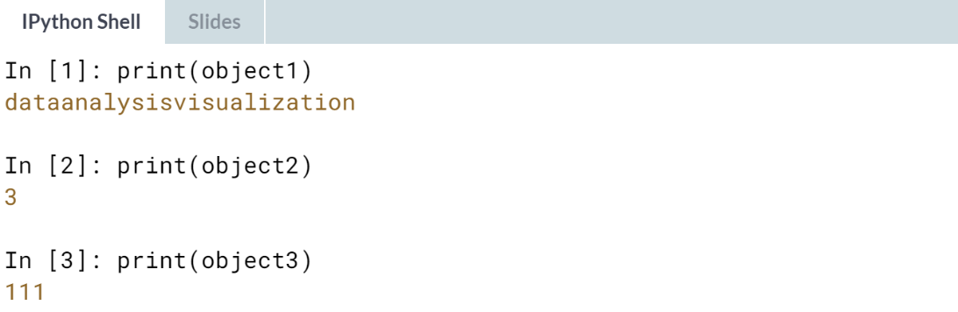

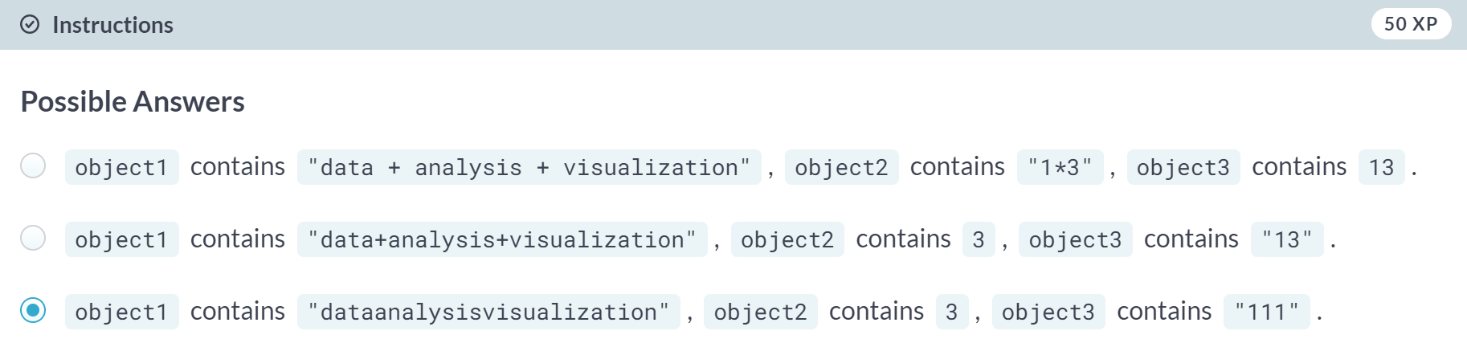

# Recapping built-in functions

In the video, Hugo briefly examined the return behavior of the built-in functions print() and str(). Here, you will use both functions and examine their return values. A variable x has been preloaded for this exercise. Run the code below in the console. Pay close attention to the results to answer the question that follows.

* Assign str(x) to a variable y1: y1 = str(x)
* Assign print(x) to a variable y2: y2 = print(x)
* Check the types of the variables x, y1, and y2.

What are the types of x, y1, and y2?  
  
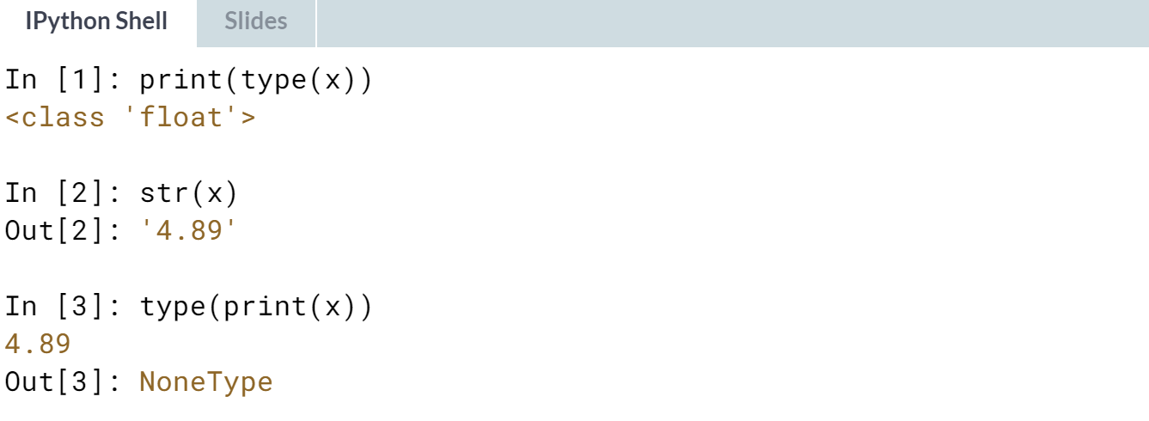

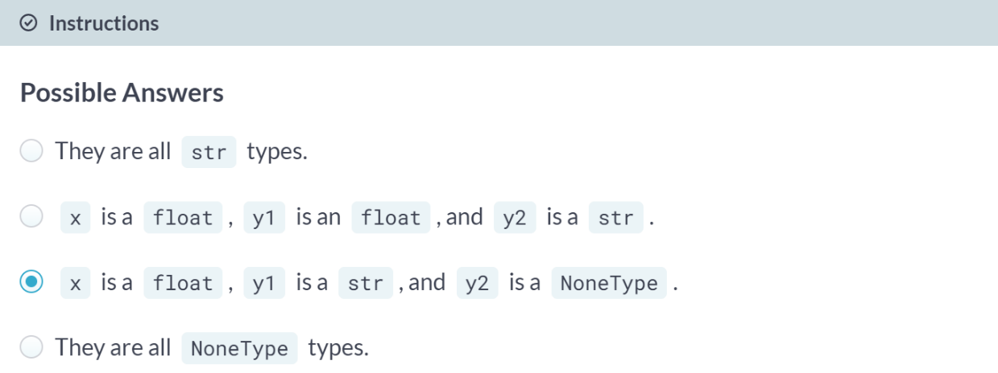  
Correct! It is important to remember that assigning a variable y2 to a function that prints a value but does not return a value will result in that variable y2 being of type *NoneType*.

# Write a simple function

In the last video, Hugo described the basics of how to define a function. You will now write your own function!

Define a function, shout(), which simply prints out a string with three exclamation marks '!!!' at the end. The code for the square() function that we wrote earlier is found below. You can use it as a pattern to define shout().

def square():

new_value = 4 ** 2

return new_value

Note that the function body is indented 4 spaces already for you. Function bodies need to be indented by a consistent number of spaces and the choice of 4 is common.

This course touches on a lot of concepts you may have forgotten, so if you ever need a quick refresher, download the [***Python for data science Cheat Sheet***](https://datacamp-community-prod.s3.amazonaws.com/e30fbcd9-f595-4a9f-803d-05ca5bf84612) and keep it handy!

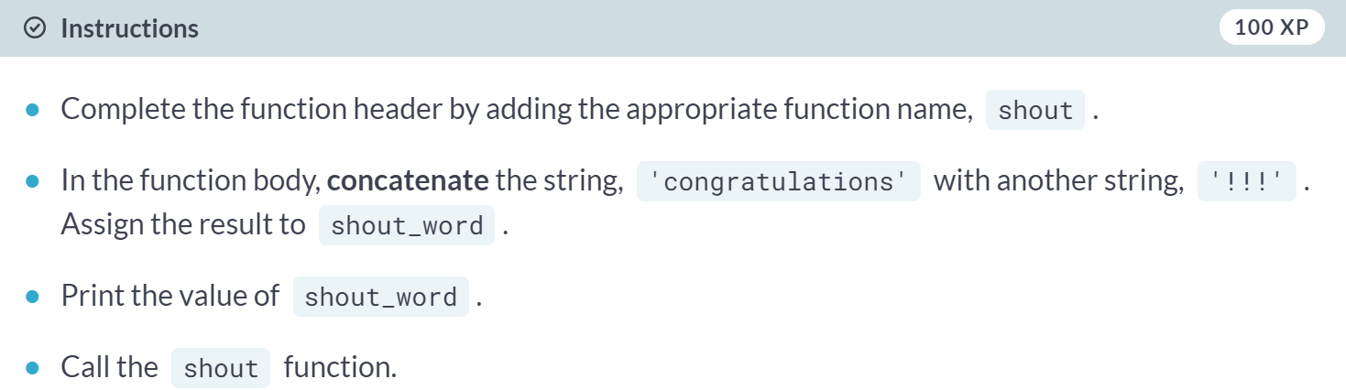  
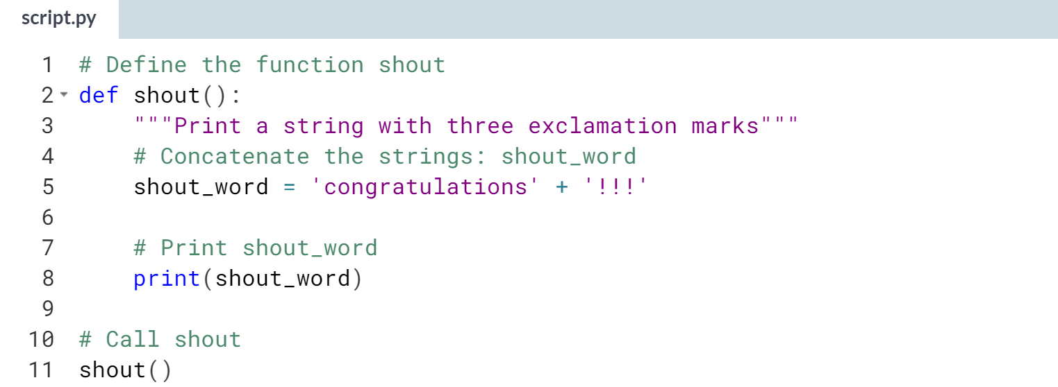  
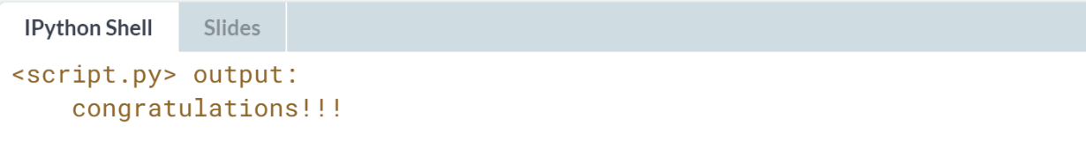

# Single-parameter functions

Congratulations! You have successfully defined and called your own function! That's pretty cool.

In the previous exercise, you defined and called the function shout(), which printed out a string concatenated with '!!!'. You will now update shout() by adding a parameter so that it can accept and process any string argument passed to it. Also note that shout(word), the part of the header that specifies the function name and parameter(s), is known as the signature of the function. You may encounter this term in the wild!

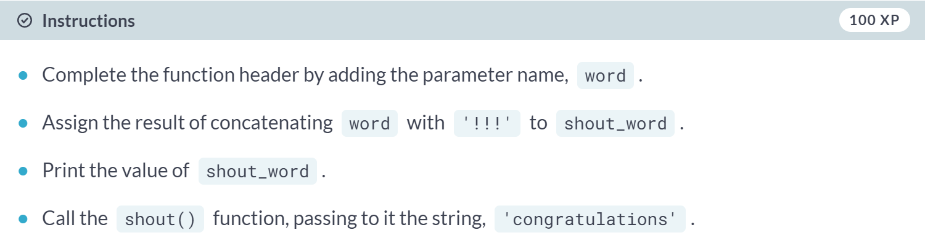

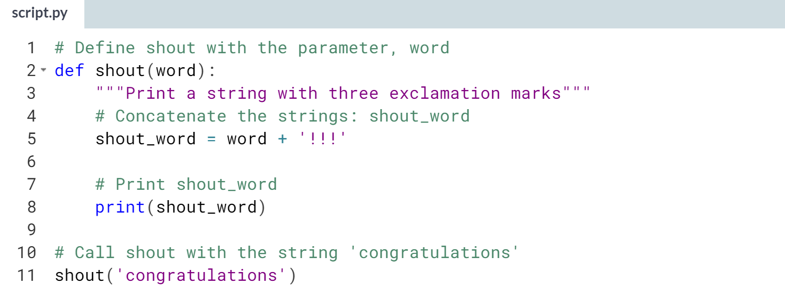  
  
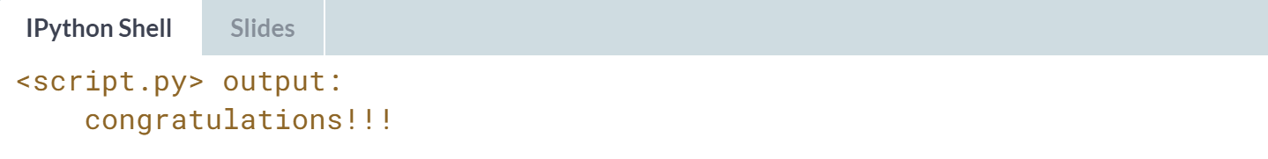

# Functions that return single values

You're getting very good at this! Try your hand at another modification to the shout() function so that it now returns a single value instead of printing within the function. Recall that the return keyword lets you return values from functions.

Parts of the function shout(), which you wrote earlier, are shown. Returning values is generally more desirable than printing them out because, as you saw earlier, a print() call assigned to a variable has type NoneType.

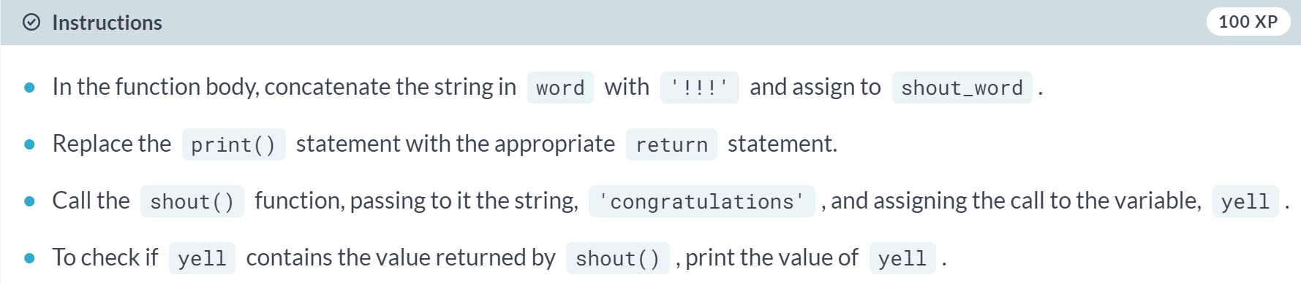  
  
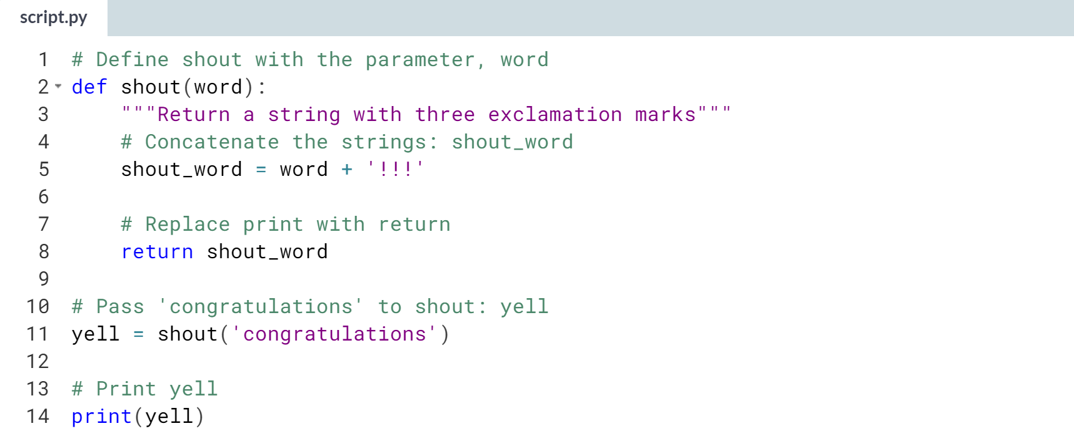  
  
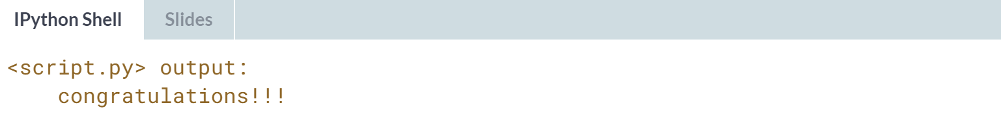  
  
Great work! Here it made sense to assign the output of shout ('congratulations') to a variable *yell* because the function shout actually returns a value, it does not merely print one.



Let's learn about how to pass multiple arguments to functions, as well as not just one, but multiple values from them. Let's tweak the square function we've been working on a little bit more.

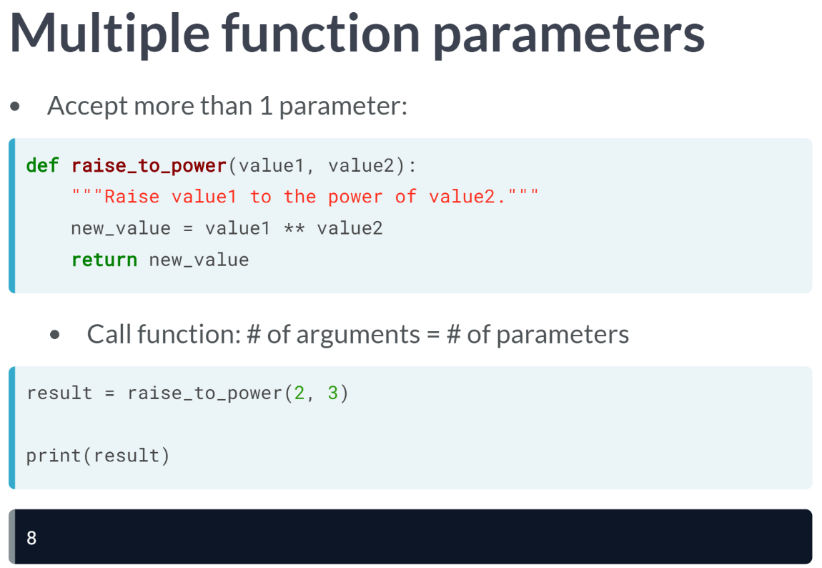  
Suppose that instead of simply squaring a value, we'd like to raise a value to the power of another value that's also passed to the function.

We can do this by having our function accept two parameters instead of just one. You should also change your function name and docstrings to reflect this new behavior. raise_to_power is an appropriate function name.

Notice that there are now two parameters in the function header instead of one, *value1* and *value2*. In the lines after that, the behavior of the overall function changes by raising *value1* to the power of *value2*.

You can call the function by passing in two arguments because the function has two parameters, as declared in the function header. The order in which the arguments are passed correspond to the order of the parameters in the function header.

This means that when we call *raise_to_power(2, 3)*, when the function is executed, 2 would be assigned to value1 and 3 to value2. Computation value 1 to the power of value2 translates to 2 to the power of 3. This function call then returns the value of 8.

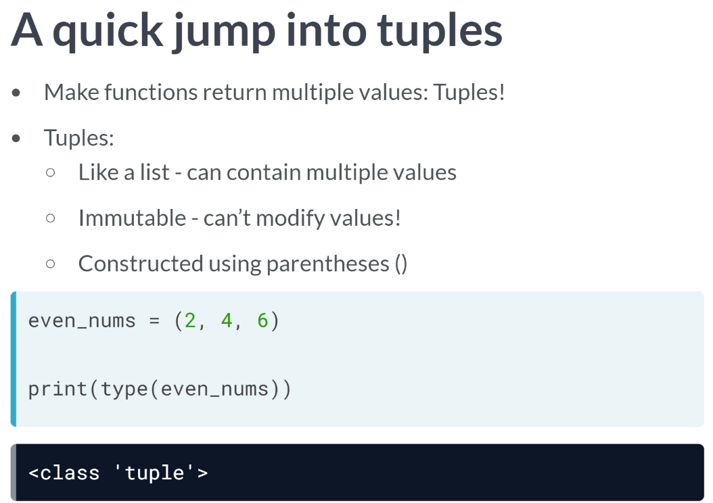  
You can also make your function return multiple values by constructing objects known as tuples in your functions. Even though tuples is similar to a list in a way that both of them can contain multiple values.

A tuple is immutable, meaning it cannot modify the values in a tuple once it has been constructed. Secondly, while lists are defined using square brackets, tuples are constructed using a set of parentheses.

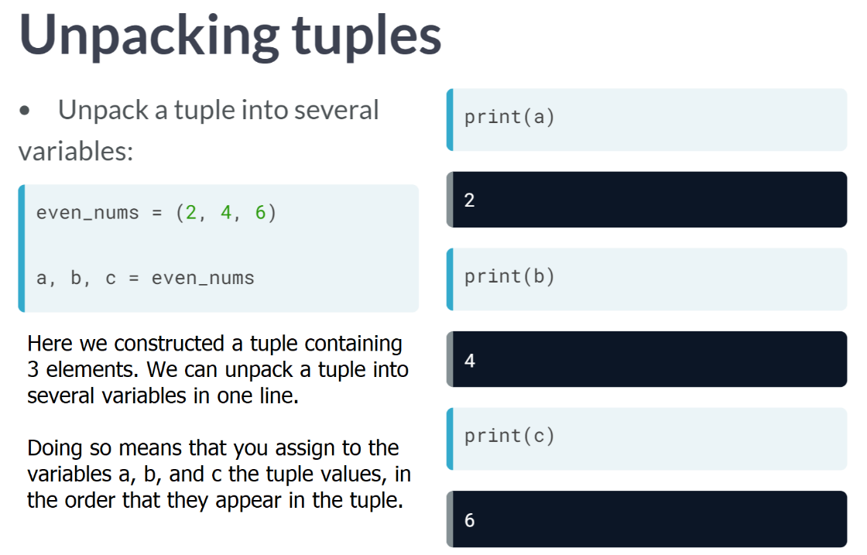

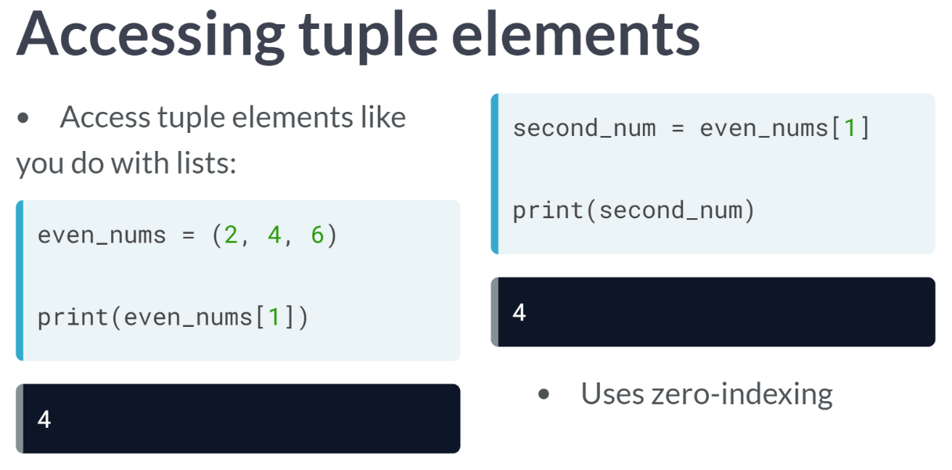  
Recall that with lists, you can use zero-indexing to access list elements. We can do the same things with tuples.

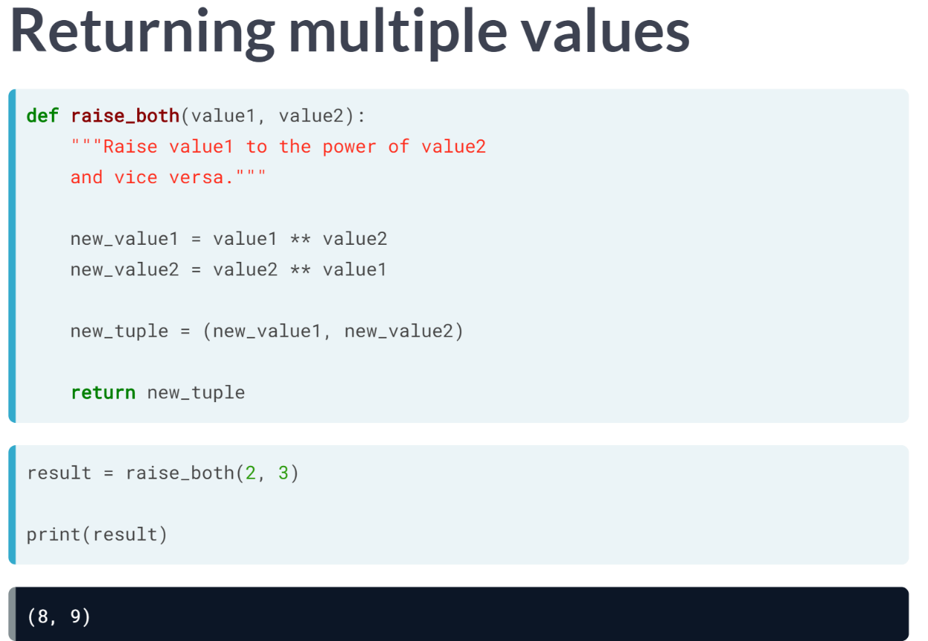  
Let's now modify the behavior of your raise function. Instead of just returning just the value of value1 raised to the power of value2, let's also return the value of value2 raised to the power of value1. Thus, you need to make raise return two values instead of one.

We can use what we now know of tuples to do this. We first change the name of our function and the docstring to reflect the new behavior of our function.

Then, in the function body, we construct a tuple consisting of the values we want the function to return and, also in the function body, we return the tuple! Calling the function constructed demonstrates that it does exactly what we want.

# Functions with multiple parameters

Hugo discussed the use of multiple parameters in defining functions in the last lecture. You are now going to use what you've learned to modify the shout() function further. Here, you will modify shout() to accept two arguments. Parts of the function shout(), which you wrote earlier, are shown.

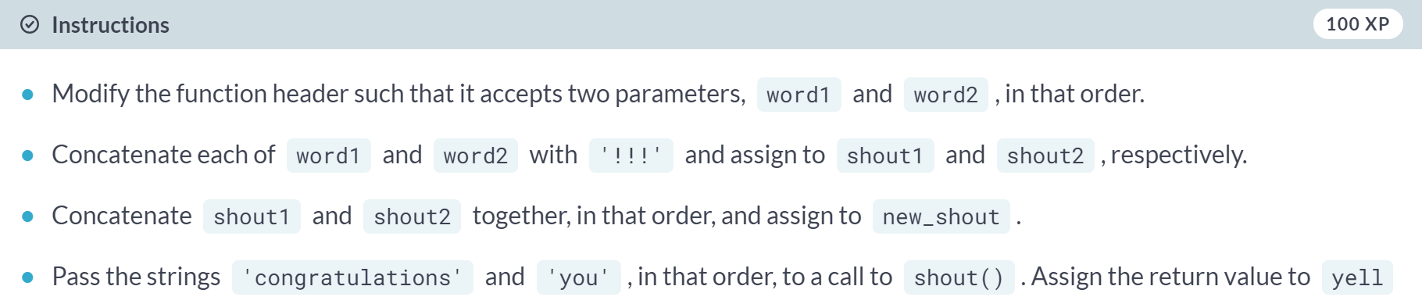

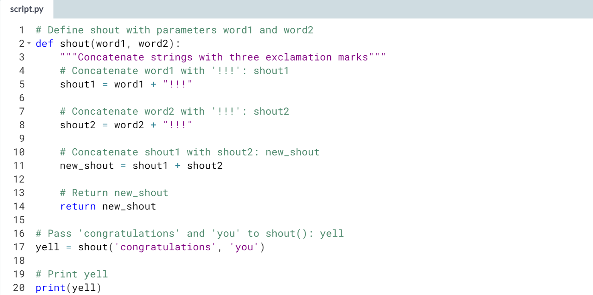

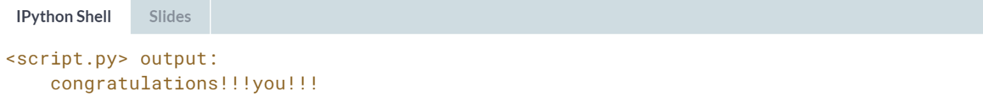

# A brief introduction to tuples

Alongside learning about functions, you've also learned about tuples! Here, you will practice what you've learned about tuples: how to construct, unpack, and access tuple elements. Recall how Hugo unpacked the tuple even_nums in the video:

a, b, c = even_nums

A three-element tuple named nums has been preloaded for this exercise. Before completing the script, perform the following:

* Print out the value of nums in the IPython shell. Note the elements in the tuple.
* In the IPython shell, try to change the first element of nums to the value 2 by doing an assignment: nums[0] = 2. What happens?

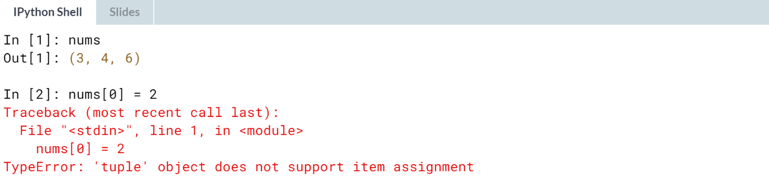

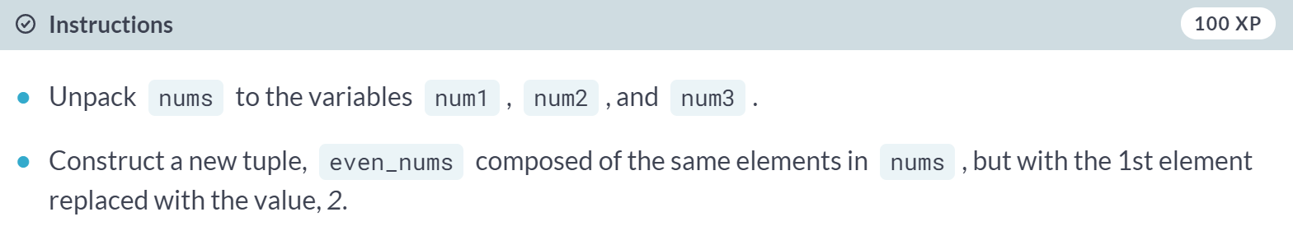

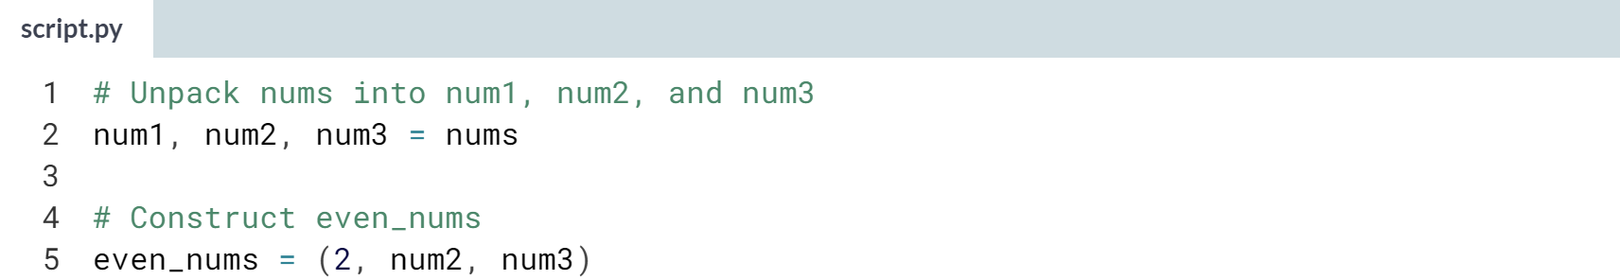

# Functions that return multiple values **(REVIEW)**

In the previous exercise, you constructed tuples, assigned tuples to variables, and unpacked tuples.

Here you will return multiple values from a function using tuples. Let's now update our shout() function to return multiple values.

Instead of returning just one string, we will return two strings with the string !!! concatenated to each.

Note that the return statement return x, y has the same result as return (x, y): the former actually packs x and y into a tuple under the hood!

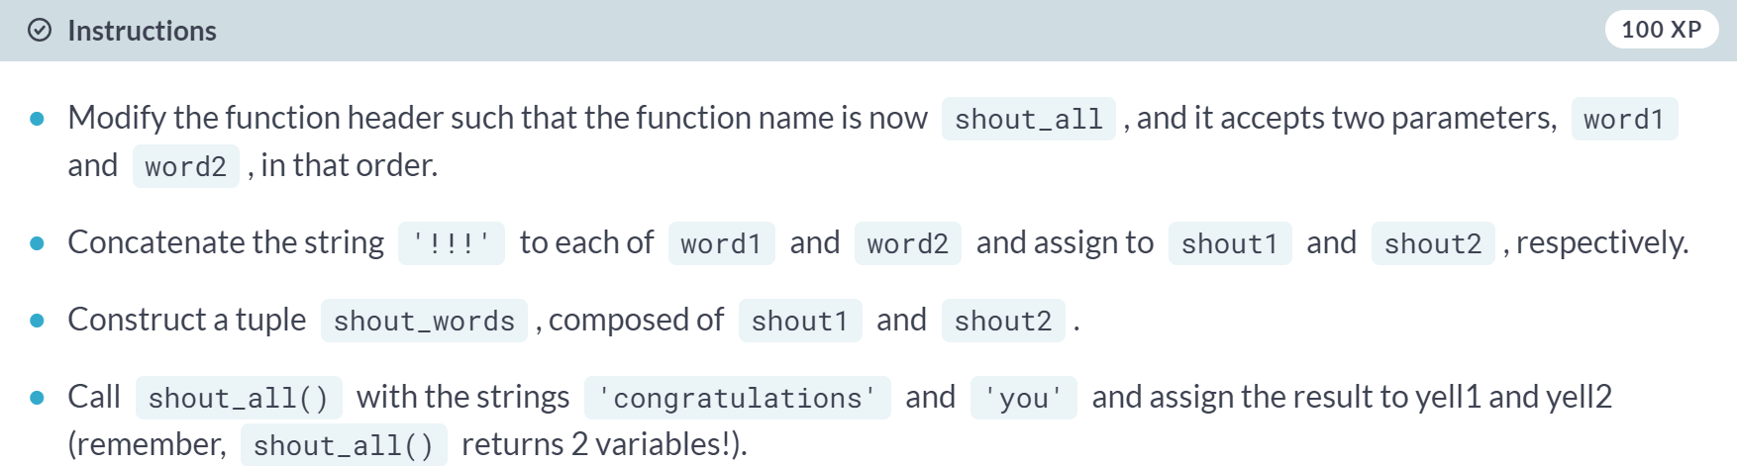  
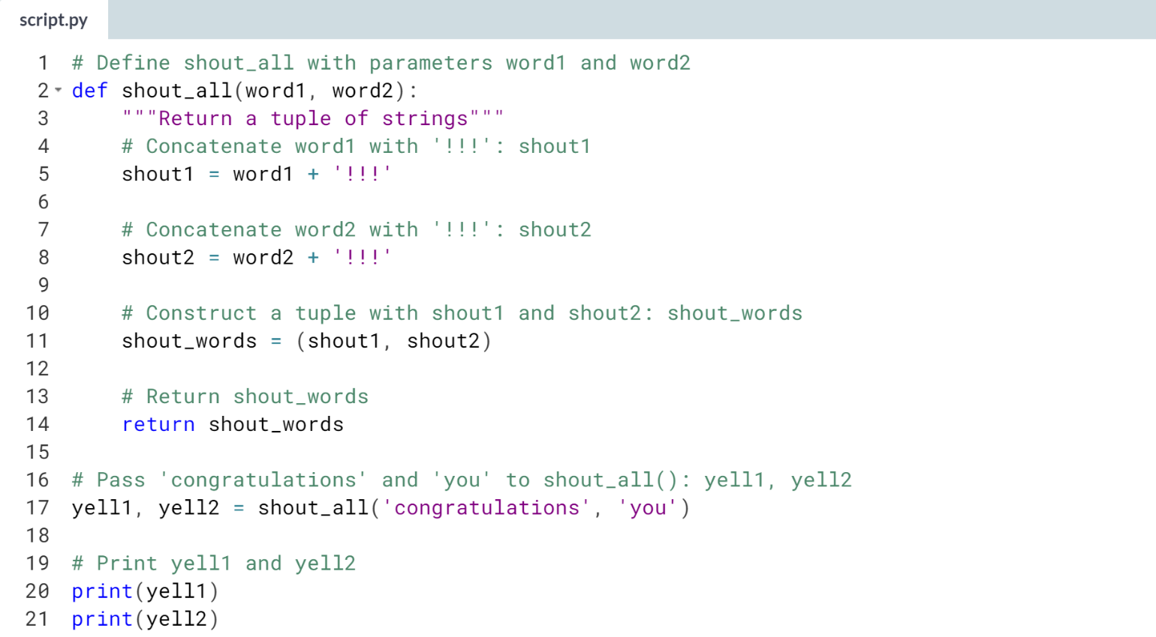  
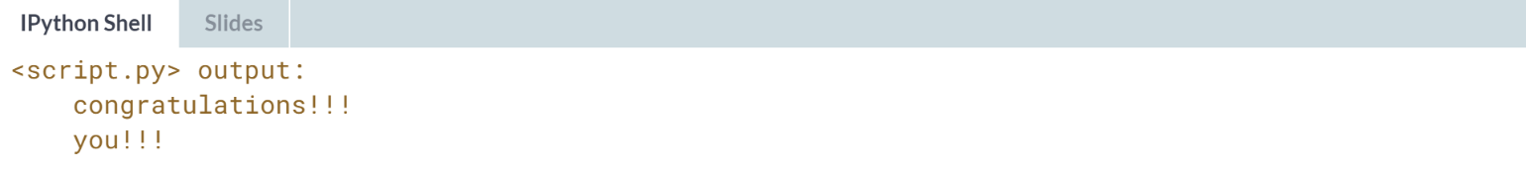

# Bringing it all together (1)

You've got your first taste of writing your own functions in the previous exercises. You've learned how to add parameters to your own function definitions, return a value or multiple values with tuples, and how to call the functions you've defined.

In this and the following exercise, you will bring together all these concepts and apply them to a simple data science problem. You will load a dataset and develop functionalities to extract simple insights from the data.

For this exercise, your goal is to recall how to load a dataset into a DataFrame. The dataset contains Twitter data and you will iterate over entries in a column to build a dictionary in which the keys are the names of languages and the values are the number of tweets in the given language. The file tweets.csv is available in your current directory.

Be aware that this is real data from Twitter and as such there is always a risk that it may contain profanity or other offensive content (in this exercise, and any following exercises that also use real Twitter data).

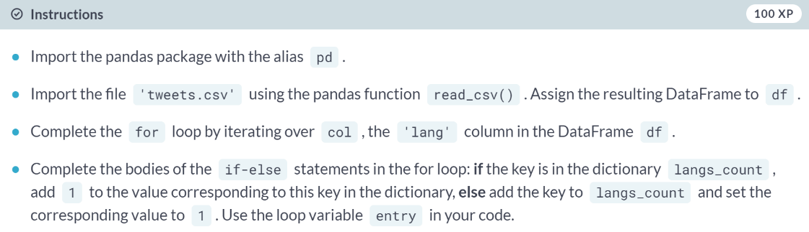  
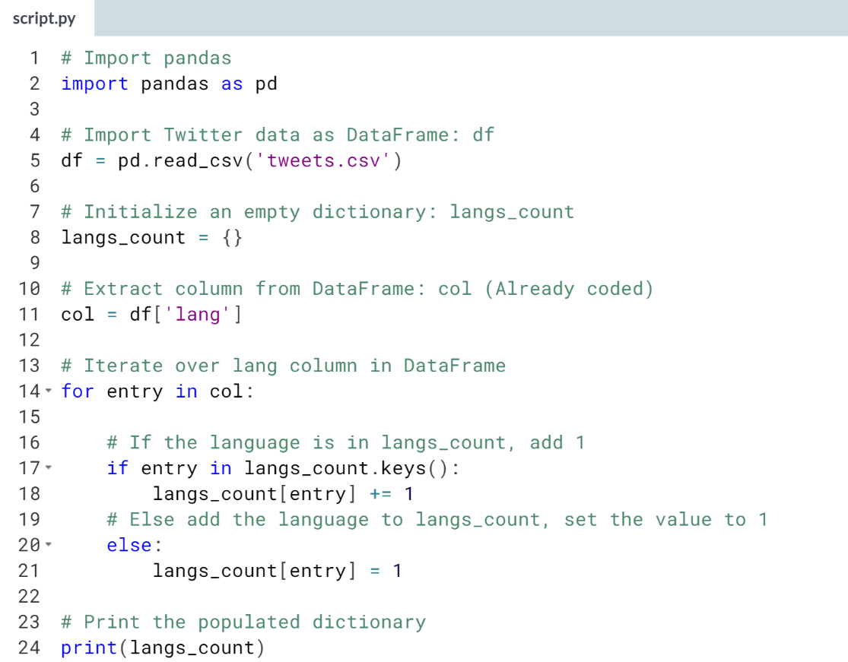  
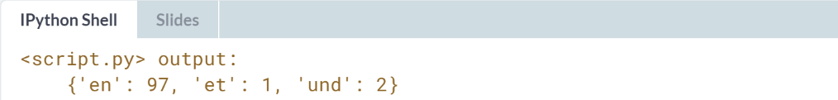

# Bringing it all together (2) – **REVIEW**

Great job! You've now defined the functionality for iterating over entries in a column and building a dictionary with keys the names of languages and values the number of tweets in the given language.

In this exercise, you will define a function with the functionality you developed in the previous exercise, return the resulting dictionary from within the function, and call the function with the appropriate arguments.

For your convenience, the pandas package has been imported as pd and the 'tweets.csv' file has been imported into the tweets_df variable.

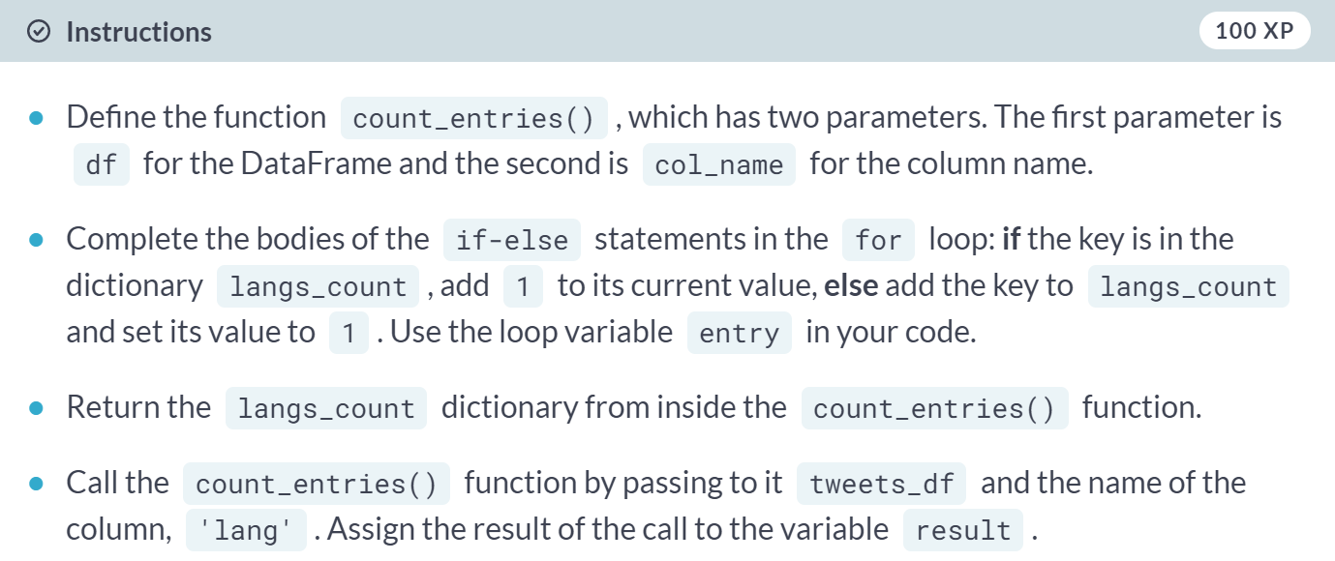

(Code on the next page)

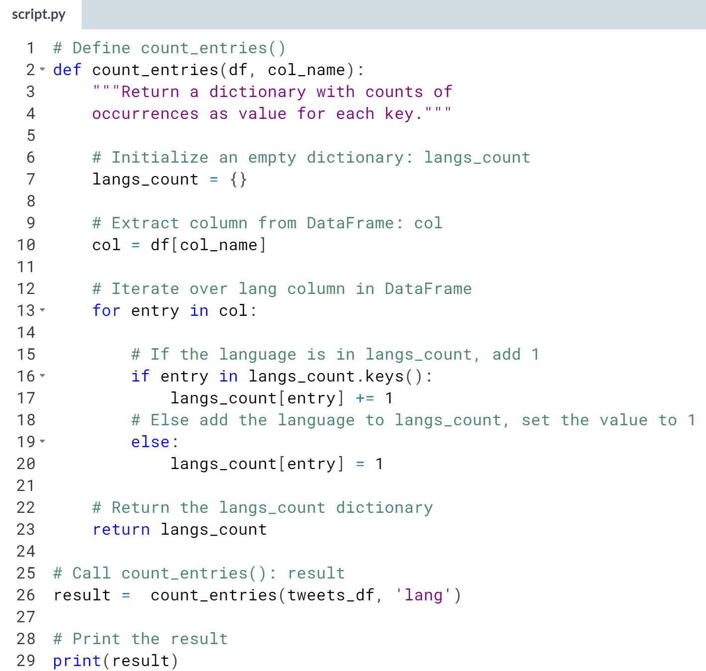

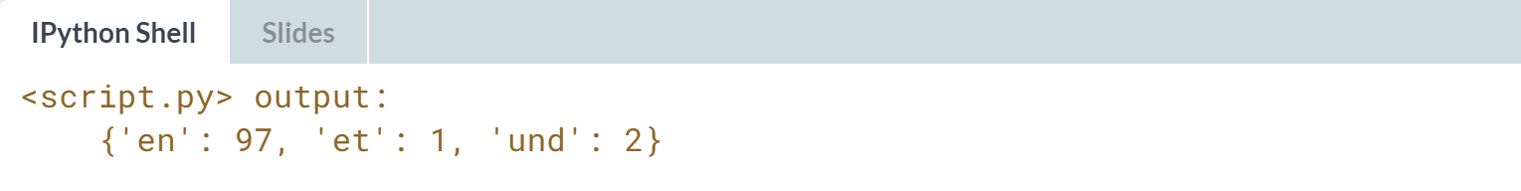



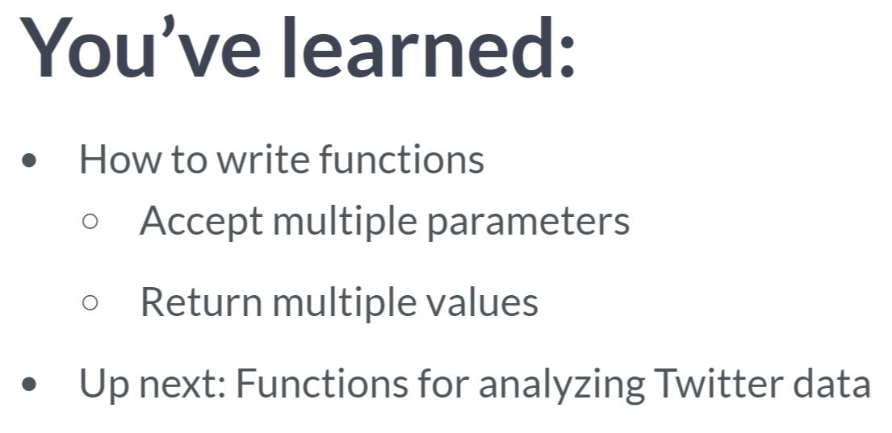  
In the following exercises, we will write a function that analyzes a DataFrame of twitter data. The function that we will write will return a dictionary containing data of how many times each language used across all the tweets in the DataFrame.

We will see later in this course that we can generalize such a function to count occurrences of an items in a DataFrame column.

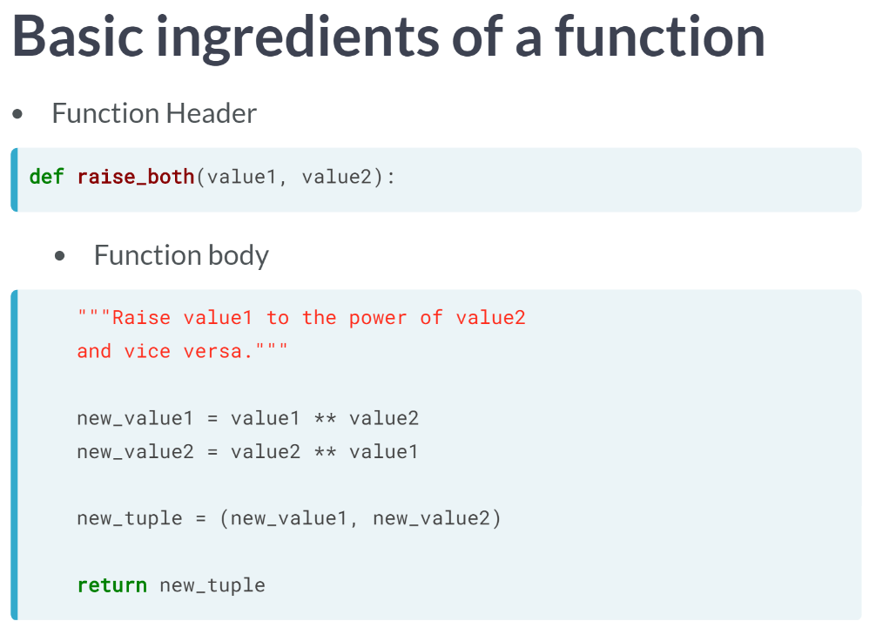  
Let's review the basic ingredients of a function.

* We have a function header, which begins with the keyword def.
* This is followed by the function name, parameters in parentheses and a colon.
* We then have the function body, which contains docstrings enclosed in triple quotation marks.
* docstrings describe what the function does.
* The rest of the function body performs the computation that the function does.
* The function body closes with the keyword return followed by the value or values returned by the function.

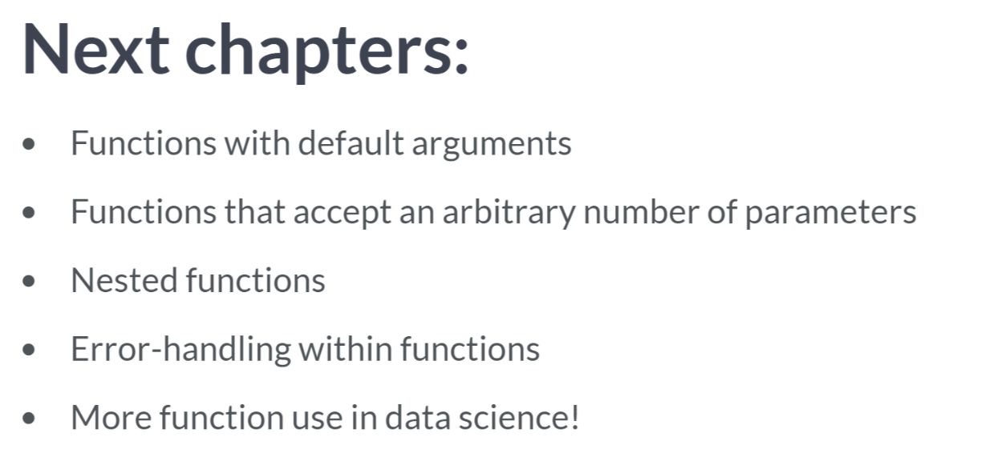  
In the following chapters, we will learn how to write functions that have default arguments so that when we call them, we don't always have to specify all the parameters.

We will also learn how to write functions that can accept a arbitrary number of parameters and how to nest functions within one another.

On top of this, we will learn how to handle errors when writing functions, which will make your functions as robust as they need to be.

Moreover, you will see the importance of such techniques in Data Science by writing functions that are pertinent to the Data Science sphere like the Twitter DataFrame analysis that we just performed.

**2. Default arguments, variable-length arguments, and scope**

In this chapter, you'll learn to write functions with default arguments so that the user doesn't always need to specify them, and variable-length arguments so they can pass an arbitrary number of arguments on to your functions. You'll also learn about the essential concept of scope.



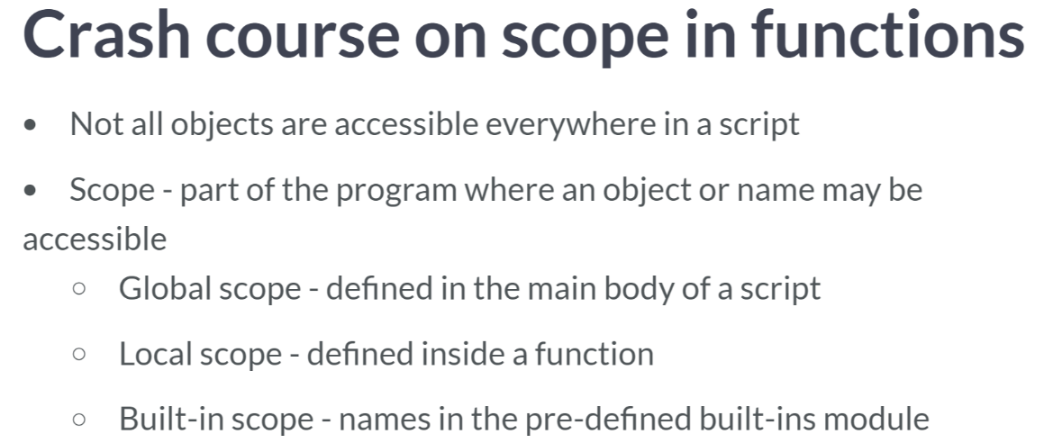

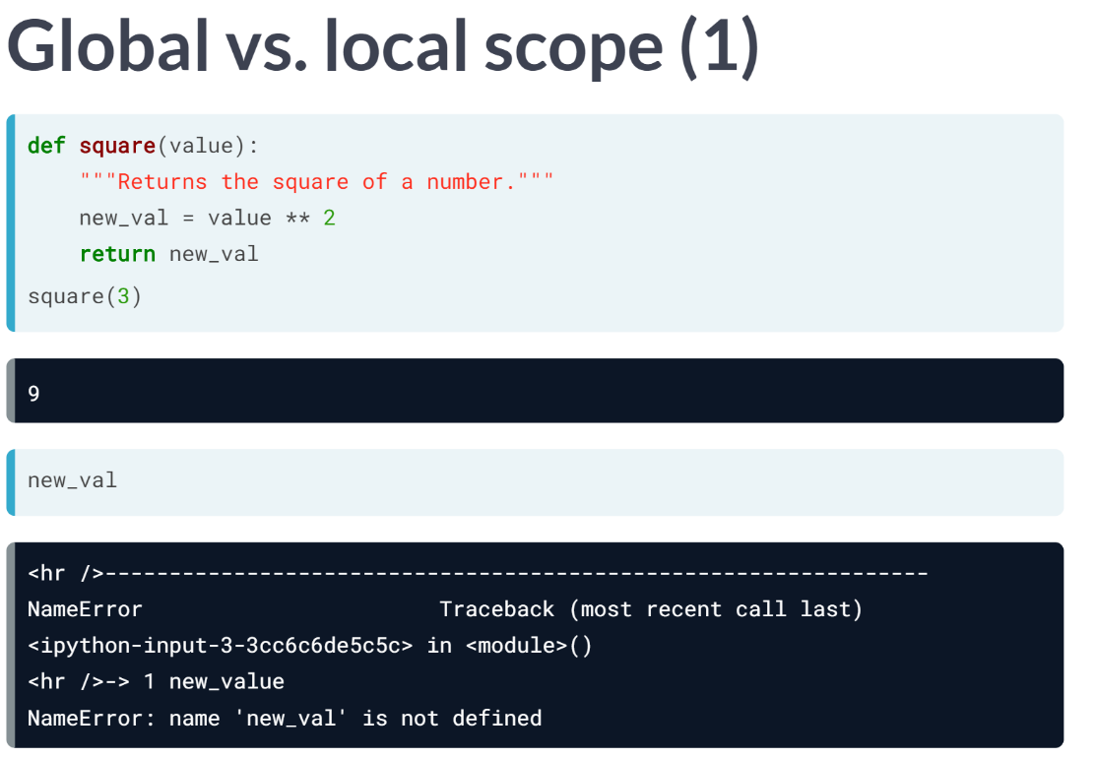  
Let's check out our example function square from earlier. We define the function and then call it. If we then try to access the variable name *new_val* after function execution, the name is not accessible.

This is because it was defined only within the local scope of the function. The name *new_val* was not defined globally.

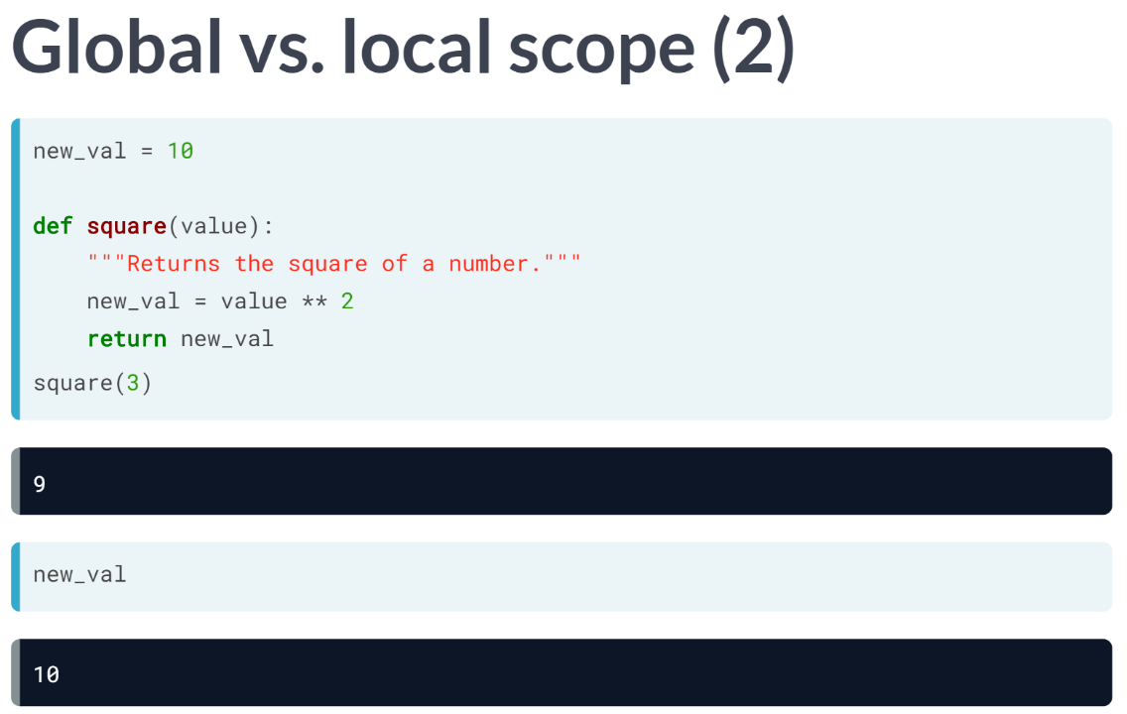  
Now what if we define the name globally before defining and calling the function? In short, any time we call the name in the global scope, it will access the name in the global, such as you see here.

Any time we call the name in the local scope of the function, it will look first in the local scope. That's why calling square(3) results in 9 and not 10. If Python cannot find the name in the local scope, it will then and only then look in the global scope.

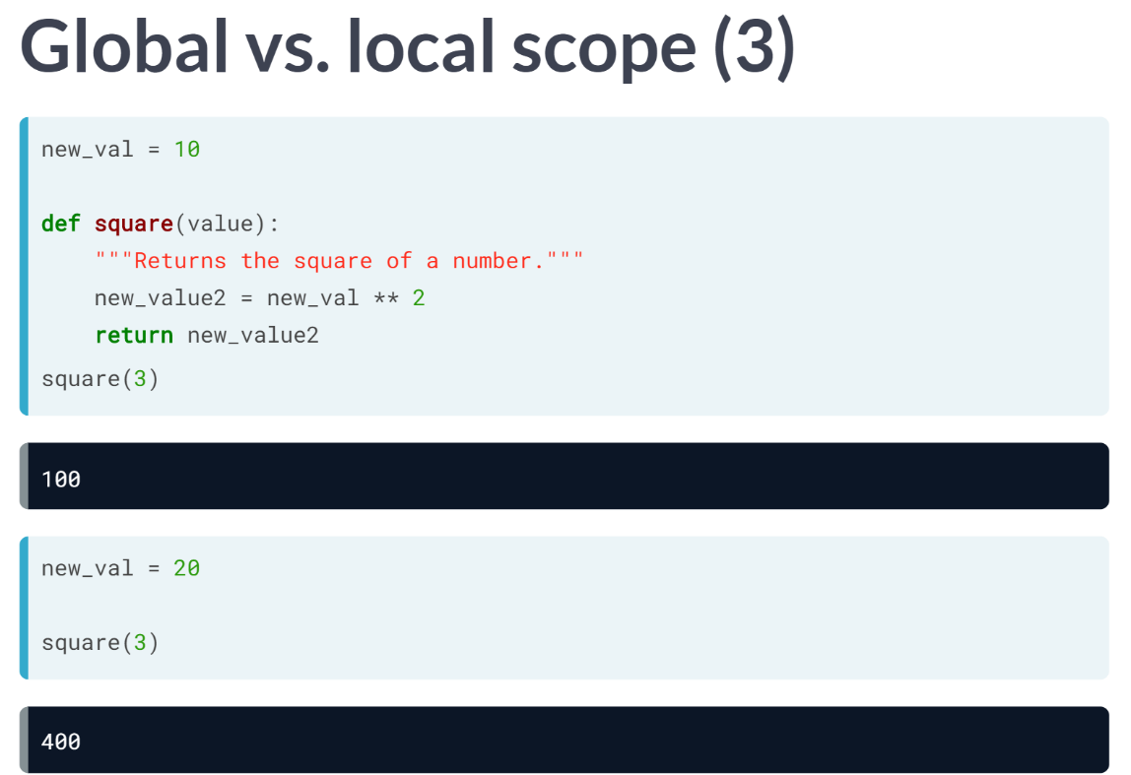  
Here, for example, we access *new_val* defined globally within the function square. Note that the global value accessed is the value at the time the function is called , not the value when the function is defined. Thus, if we re-assign *new_val* and call the function square, we see that the new value of *new_val* is accessed.

To recap, when we reference a name, first the local scope is searched, then the global. If the name is in neither, then the built-in scope is searched.

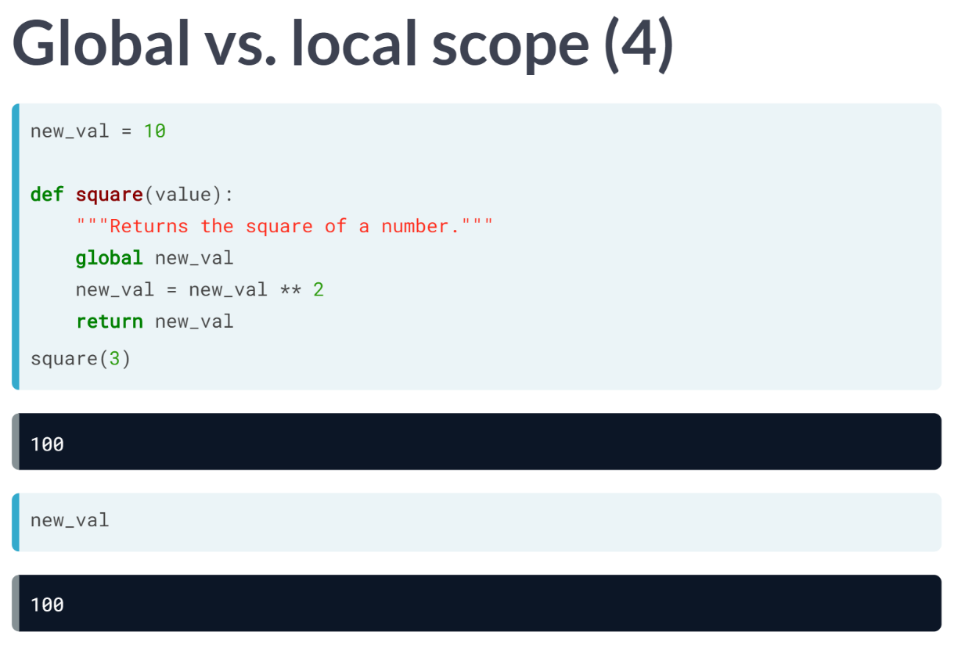  
Now what if we want to alter the value of a global name within a function call? This is where the keyword global comes in handy.

Within the function definition above, we use the keyword *global* followed by the name of the global variable that we wish to access and alter.

Here we change *new_val* to its square. The function call works as one would expect.

Now calling *new_val*, we see that the global value has indeed been squared by running the function ***square()***.

# Pop quiz on understanding scope

In this exercise, you will practice what you've learned about scope in functions. The variable num has been predefined as 5, alongside the following function definitions:

def func1():

num = 3

print(num)

def func2():

global num

double_num = num * 2

num = 6

print(double_num)

Try calling func1() and func2() in the shell, then answer the following questions:

* What are the values printed out when you call func1() and func2()?
* What is the value of num in the global scope after calling func1() and func2()?

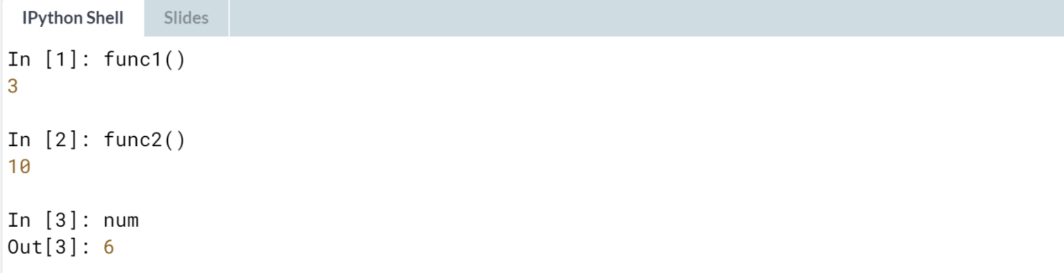

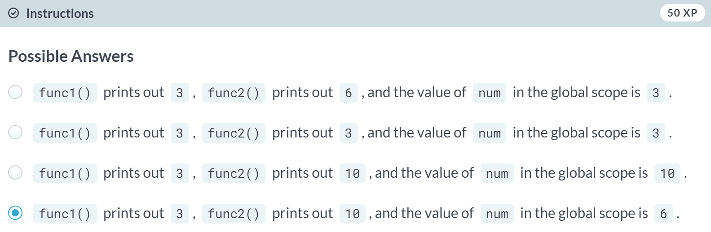

# The keyword global

Let's work more on your mastery of scope. In this exercise, you will use the keyword global within a function to alter the value of a variable defined in the global scope.

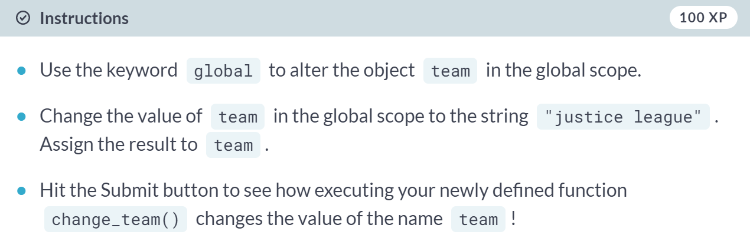  
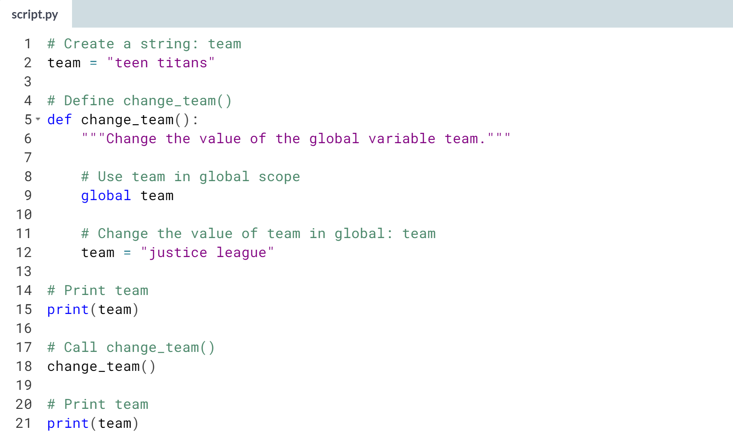  
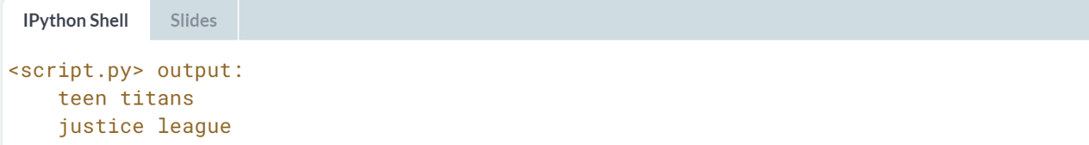

# Python's built-in scope

Here you're going to check out Python's built-in scope, which is really just a built-in module called builtins. However, to query builtins, you'll need to import builtins 'because the name builtins is not itself built in...No, I’m serious!' ([**Learning Python, 5th edition**](http://shop.oreilly.com/product/0636920028154.do), Mark Lutz).

After executing import builtins in the IPython Shell, execute dir(builtins) to print a list of all the names in the module builtins. Have a look and you'll see a bunch of names that you'll recognize! Which of the following names is NOT in the module builtins?

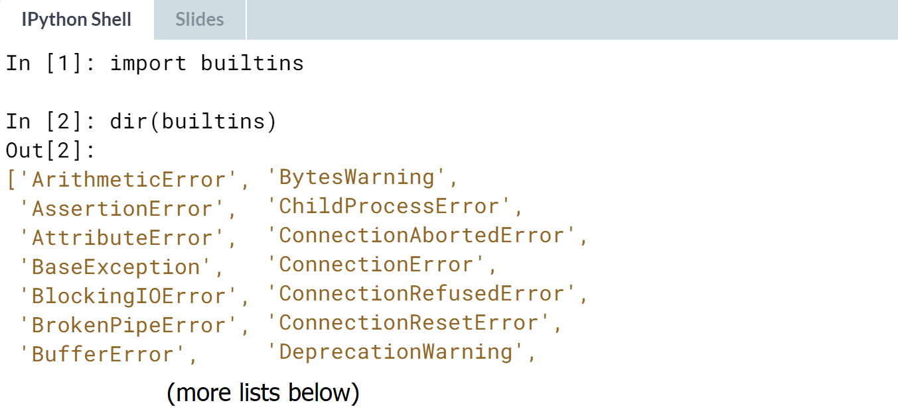

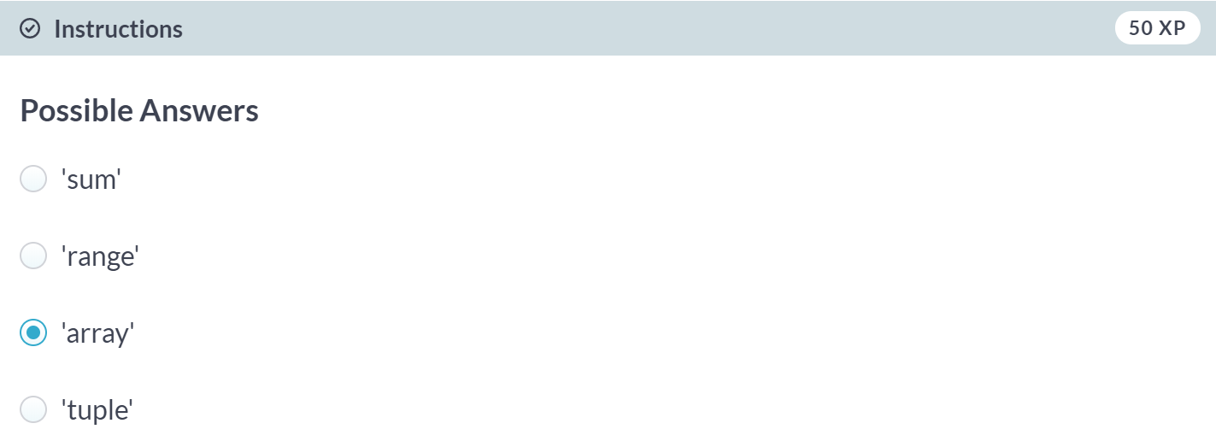



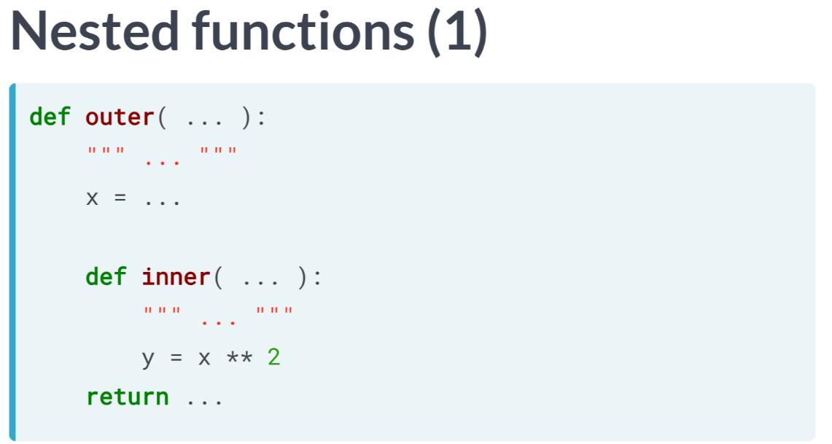  
What if we have a function ***inner()*** defined within another function ***outer()***, and we reference a name *x* in the inner function? The answer is intuitive: Python searches the local scope of the function inner, then if it doesn't find *x*, it searches the scope of the function outer, which is called an enclosing function because it encloses the function inner.

If Python can't find *x* in the scope of the enclosing function, it only then searches the global scope and then the built-in scope. But why are we even nesting the function in the first place? There are number of good reasons to do so.

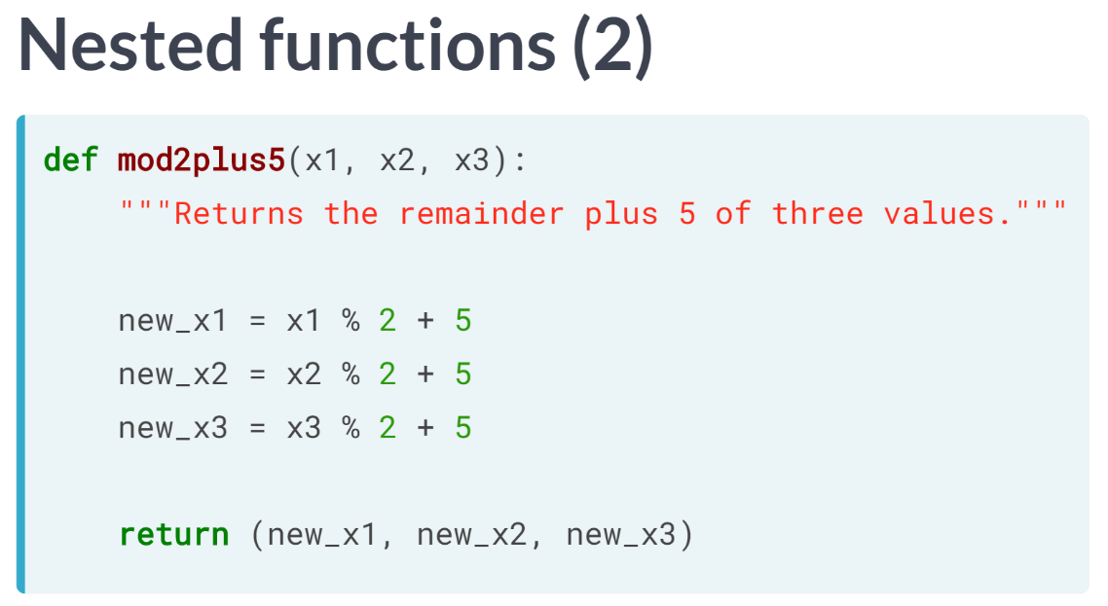  
Let's say that we want to use a process a number of times within a function. For example, we want a function that takes three numbers as parameters and performs the same function on each of them.

One way would be to write out the computation 3 times, but this definitely does not scale if you need to perform the computation many times.

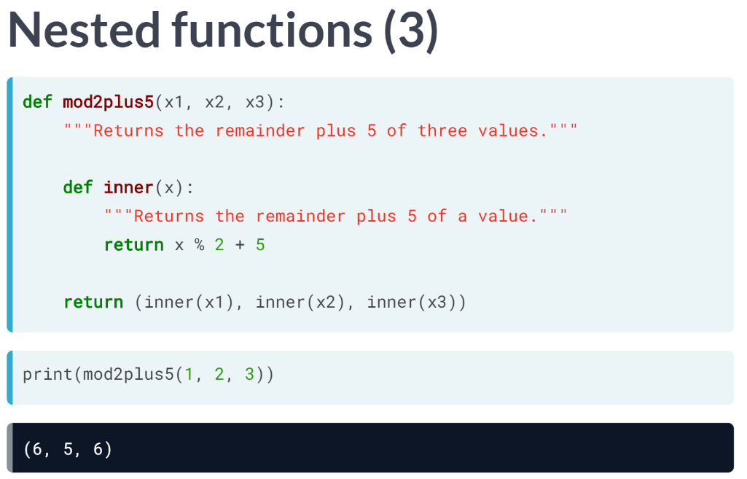  
What we can do instead is define an inner function within our function definition, such as we do here, and call it where necessary. This is called a **nested function**.

The syntax for the inner function is exactly the same as that for any other function.

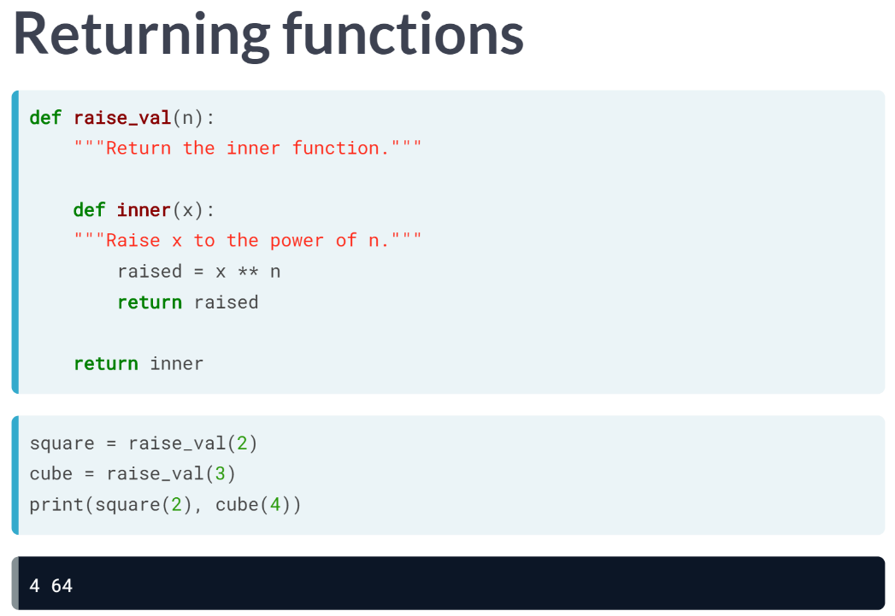  
Let's now look at another important use case of nested functions. In this example, we define a function *raise_val*, which contains an inner function called ***inner()***. Now, look at what *raise_val* returns: it returns the inner function ***inner()***! *raise_val* takes an argument *n* and creates a function inner that returns the nth power of any number.

That's a bit complicated and will be clearer when we use the function *raise_val*. Passing the number 2 to *raise_val* creates a function that squares any number. Similarly, passing the number 3 creates a function to *raise_val* creates a function that cubes any number.

One interesting detail: when we call the function square, it remembers that value n=2, although the enclosing scope defined by *raise_val* and to which n=2 is local, has finished execution. This is a subtlety referred to as a **closure** in Computer Science circles and shouldn't concern us too much.

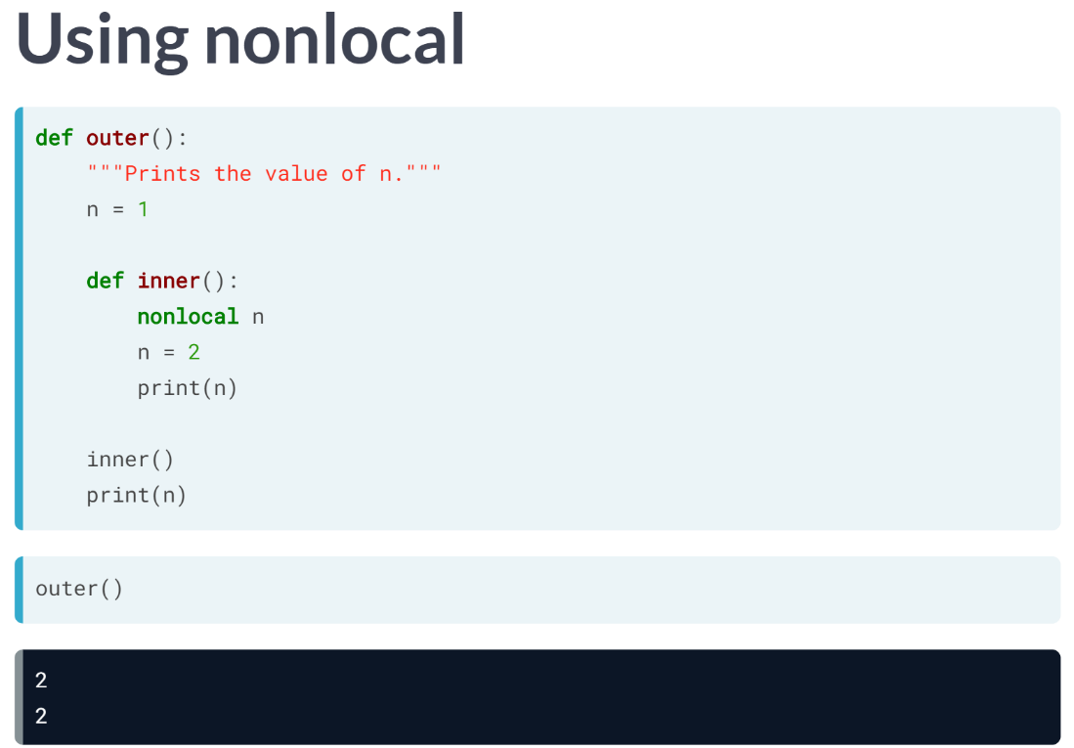  
Recall from our discussion of scope that we can use the keyword global in function definitions to create and change global names; similarly, in a nested function, you can use the keyword nonlocal to create and changes names in an enclosing scope.

In this example, we alter the value of n in the inner function; because we used the keyword nonlocal, it also alters the value of n in the enclosing scope. This is why the calling the function ***outer()*** prints the value of n as determined within the function inner. We will have practice exercises using the keyword nonlocal.

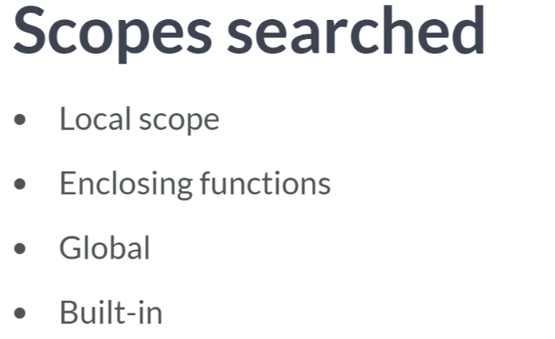  
To summarize: name references search at most four scopes, the local scope, then those of enclosing functions, if there any any; then global, then built-in. This is known as the LEGB rule, where L is for local, E for enclosing, G for global, and B for built-in.

Also, remember that assigning names will only create or change local names, unless they are declared in global or nonlocal statements using the keyword global or the keyword nonlocal, respectively.

# Nested Functions I

You've learned in the last video about nesting functions within functions. One reason why you'd like to do this is to avoid writing out the same computations within functions repeatedly. There's nothing new about defining nested functions: you simply define it as you would a regular function with def and embed it inside another function!

In this exercise, inside a function three_shouts(), you will define a nested function inner() that concatenates a string object with !!!. three_shouts() then returns a tuple of three elements, each a string concatenated with !!! using inner(). Go for it!

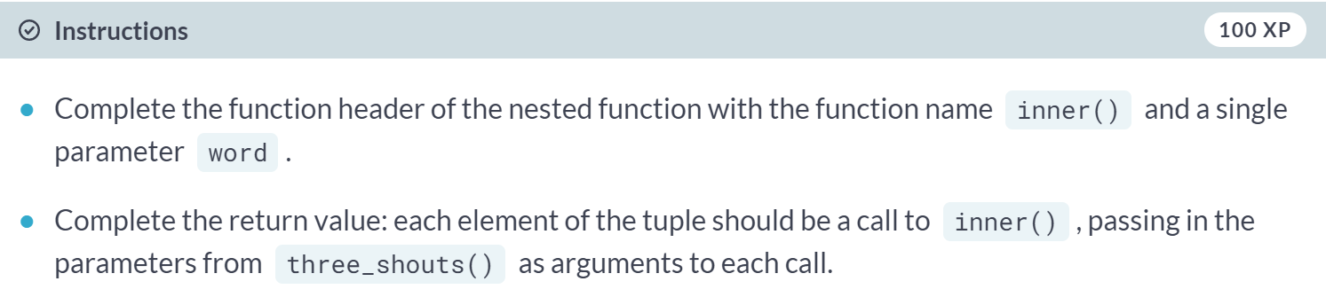  
  
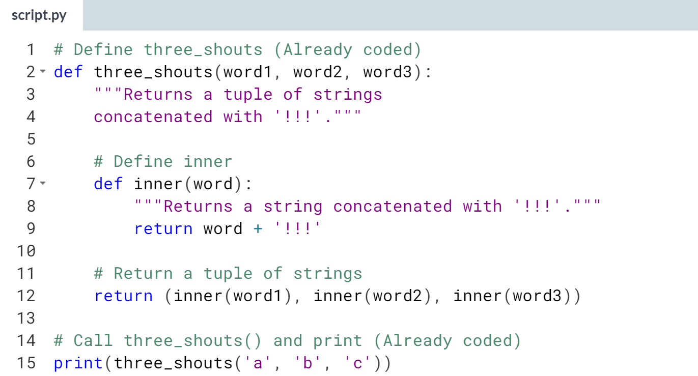  
  
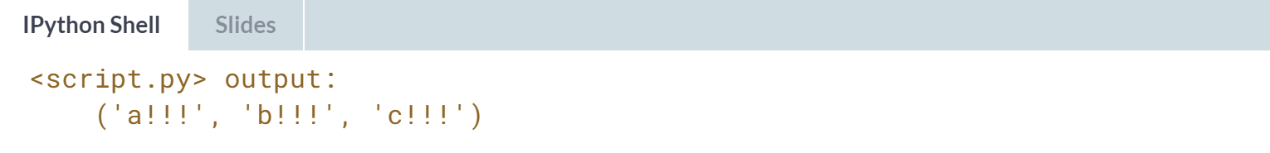

# Nested Functions II

Great job, you've just nested a function within another function. One other pretty cool reason for nesting functions is the idea of a **closure**. This means that the nested or inner function remembers the state of its enclosing scope when called. Thus, anything defined locally in the enclosing scope is available to the inner function even when the outer function has finished execution.

Let's move forward then! In this exercise, you will complete the definition of the inner function inner_echo() and then call echo() a couple of times, each with a different argument. Complete the exercise and see what the output will be!

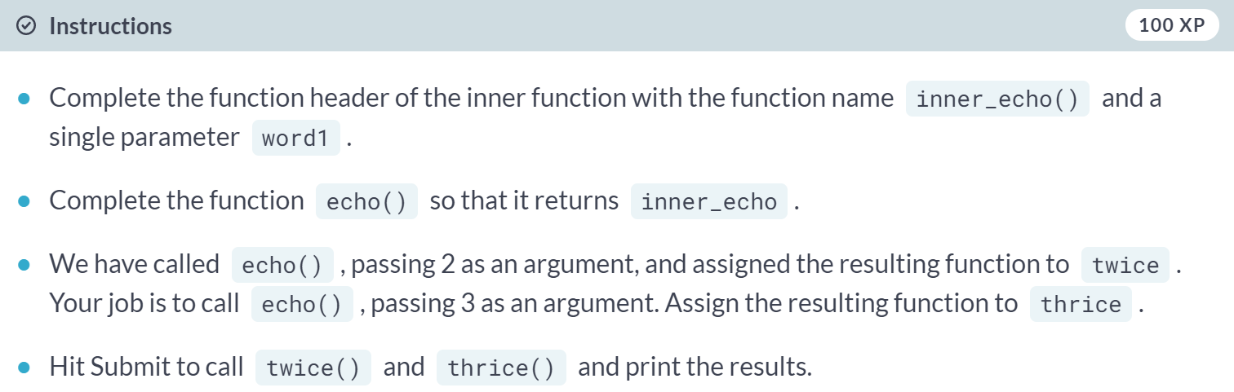

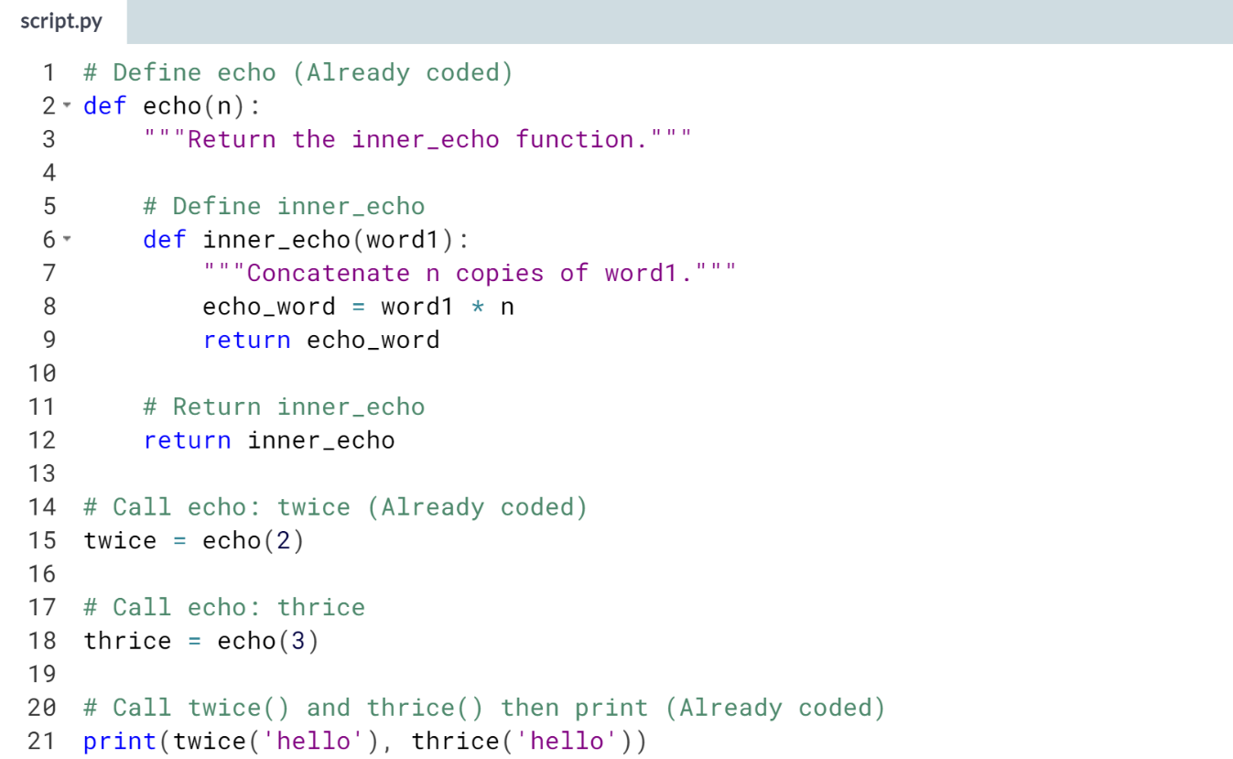  
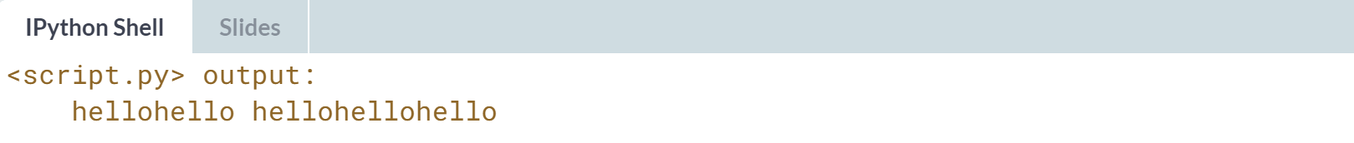

# The keyword nonlocal and nested functions

Let's once again work further on your mastery of scope! In this exercise, you will use the keyword nonlocal within a nested function to alter the value of a variable defined in the enclosing scope.

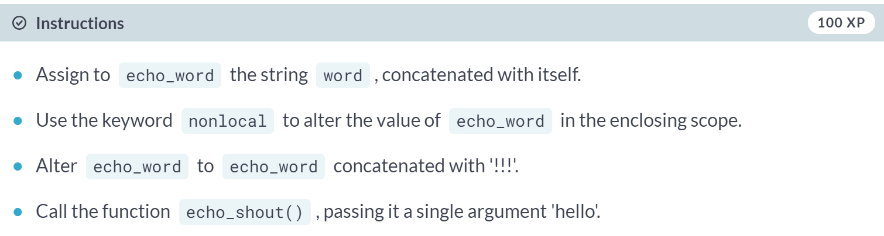  
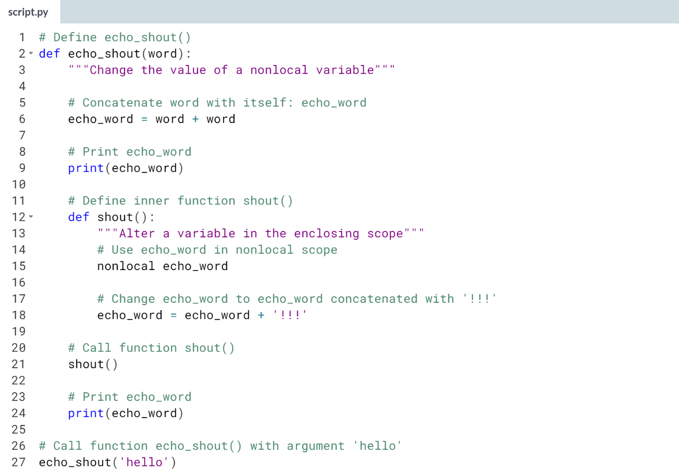

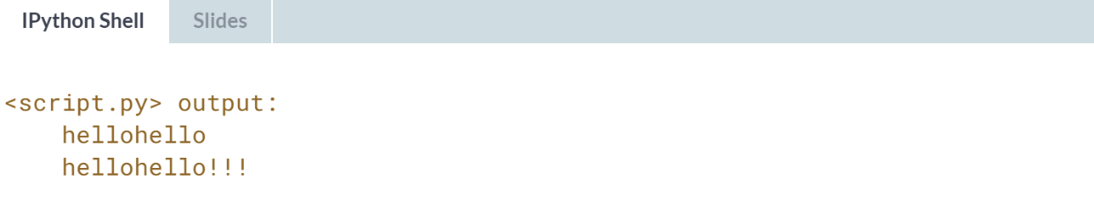



Let's say that we are writing a function that takes multiple parameters and that there is often a common value for some of these parameters. In this case, we would like to be able to **call the function without explicitly specifying** every parameter.

In other words, we would like some parameters to have default arguments that are used when it is not specified otherwise.

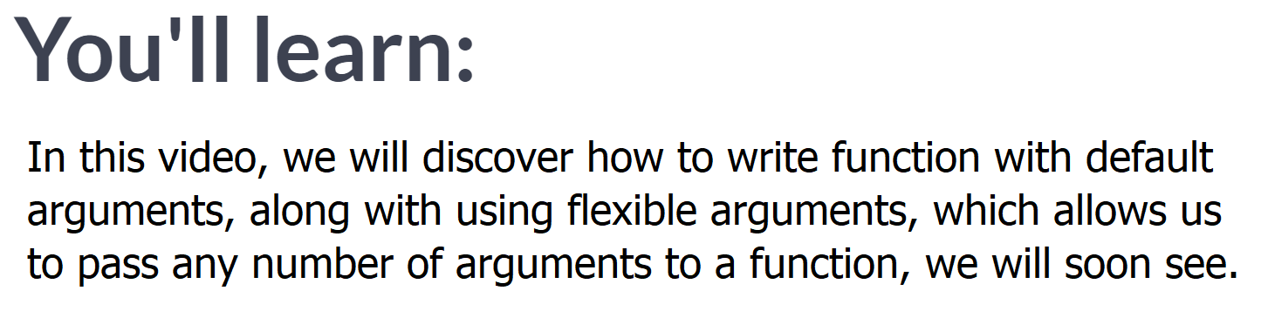

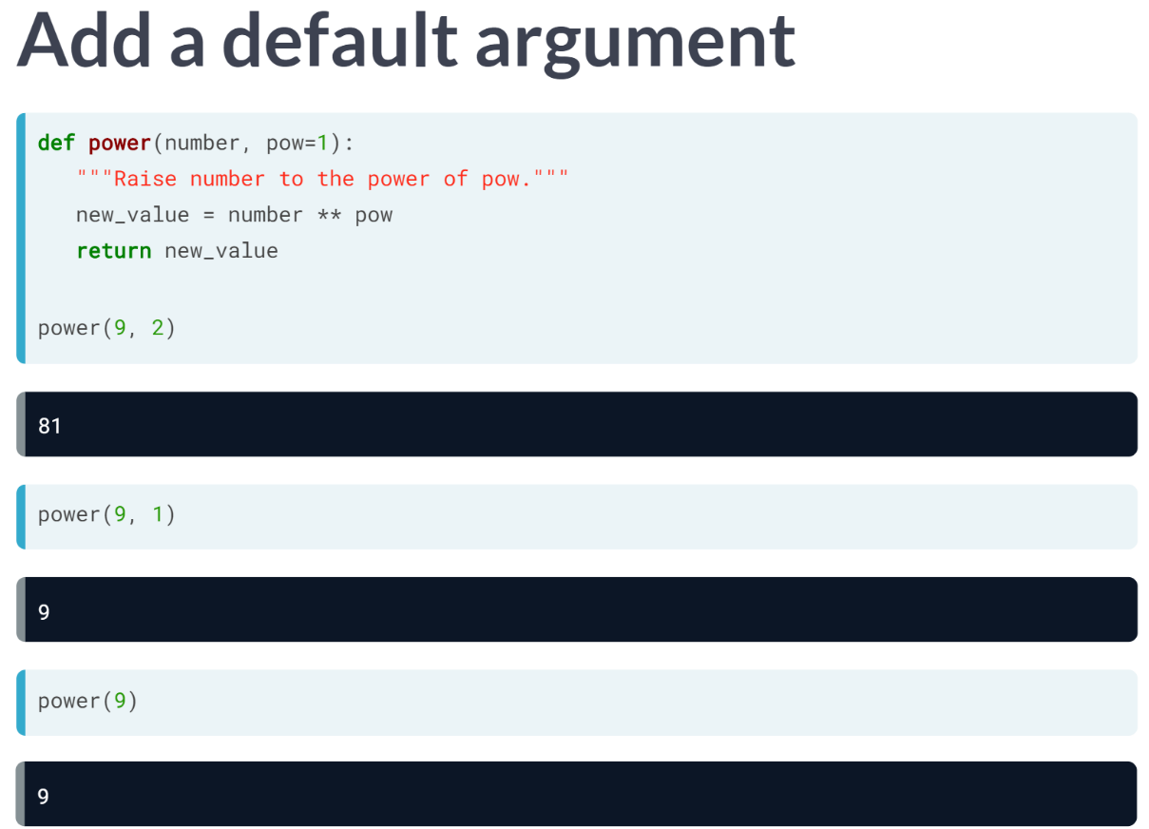  
First up, to define a function with a default argument value, in the function header we follow the parameters of interest with an equals sign and the default argument value.

Notice that this function raises the 1st argument to the power of the 2nd argument, and the default 2nd argument value is 1.

So, we can call the function with two arguments as you would expect, however, if you use only one argument, the function call will use the default argument of 1 for the second parameters. Neat!

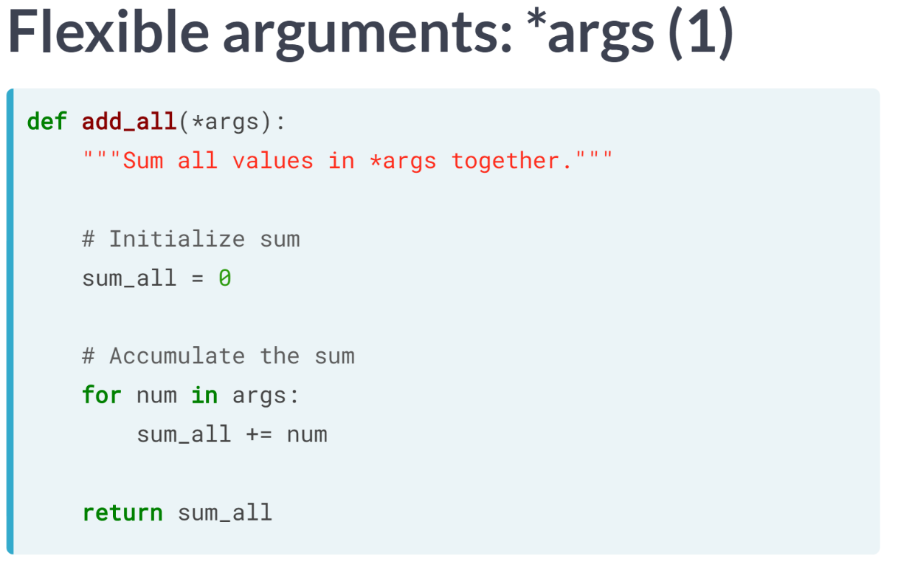  
Let's now look at flexible arguments. Let's say that you want to write a function but aren't sure how many arguments a user will want to pass it.

For example, a function that takes floats or ints and adds them all up, irrespective of how many there are. Enter flexible arguments!

In this example, we write the function that sums up all the arguments passed to it.

In the function definition, we use the parameter star followed by *args*: this then turns all the arguments passed to a function call into a tuple called *args* in the function body.

Then, in the function body, to write our desired function, we initialize our sum *sum_all* to 0, loop over the tuple args and add each element of it successively to *sum_all* and then return it.

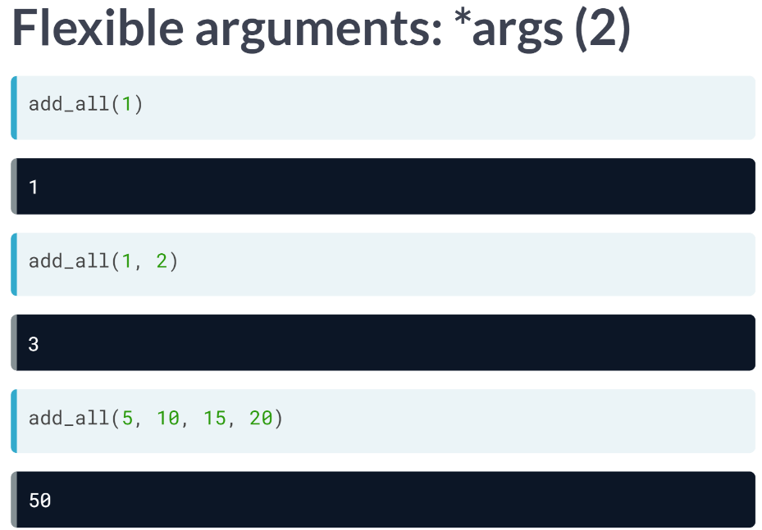  
We can now call our function *add_all* with any number of arguments to add them all up.

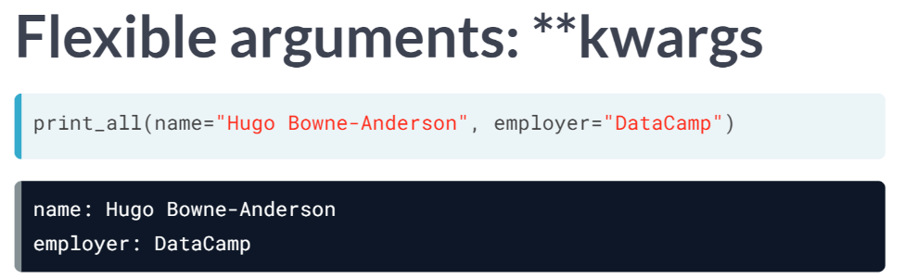  
We can also use a double star to pass an arbitrary number of keyword arguments, also called *kwargs*, that is, arguments preceded by identifiers. We will write such a function called *print_all* that prints out the identifiers and the parameters passed to them as you see here.  
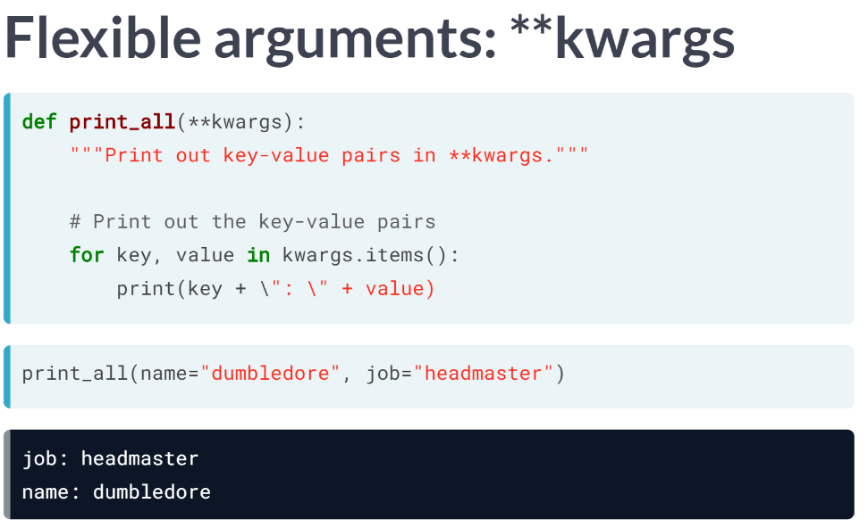  
Now to write such a function, we use the parameter *kwargs* preceded by a double star. This turns the identifier-keyword pairs into a dictionary within the function body. Then, in the function body, all we need to do is print all the *key:value* pairs stored in the dictionary *kwargs*.

Note that it is not the names *args* and *kwargs* that are important when using flexible arguments, but rather that they are preceded by a single and double star, respectively.

# Functions with one default argument

In the previous chapter, you've learned to define functions with more than one parameter and then calling those functions by passing the required number of arguments. In the last video, Hugo built on this idea by showing you how to define functions with default arguments. You will practice that skill in this exercise by writing a function that uses a default argument and then calling the function a couple of times.

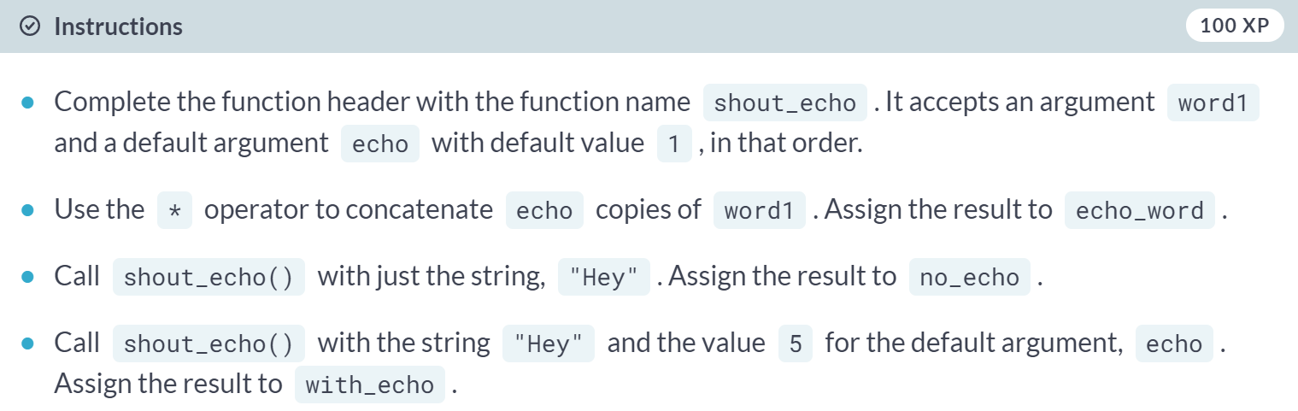  
  
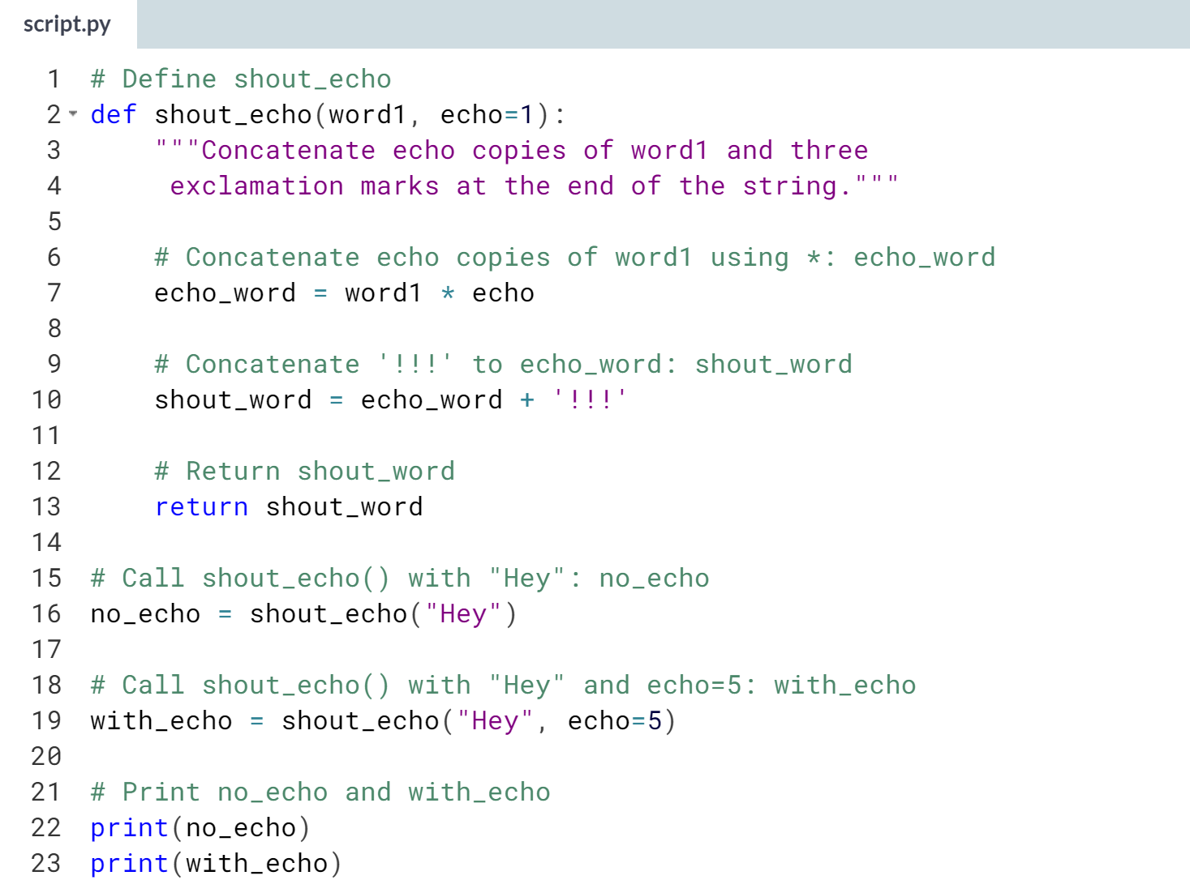  
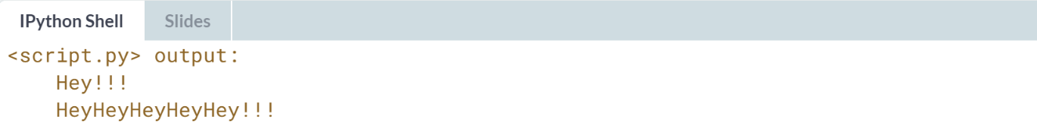

# Functions with multiple default arguments

You've now defined a function that uses a default argument - don't stop there just yet! You will now try your hand at defining a function with more than one default argument and then calling this function in various ways.

After defining the function, you will call it by supplying values to all the default arguments of the function. Additionally, you will call the function by not passing a value to one of the default arguments - see how that changes the output of your function!

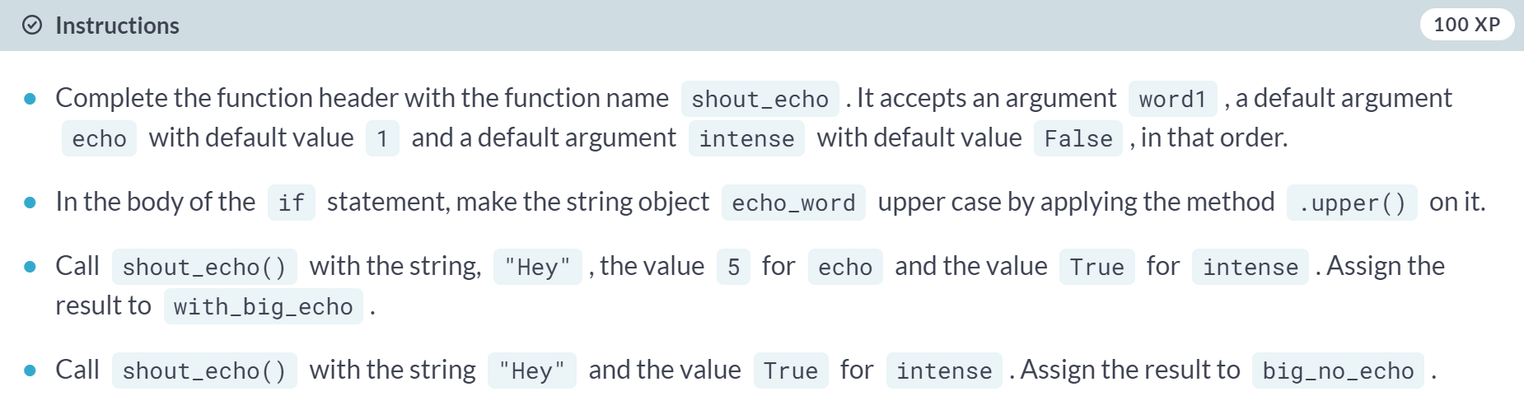  
  
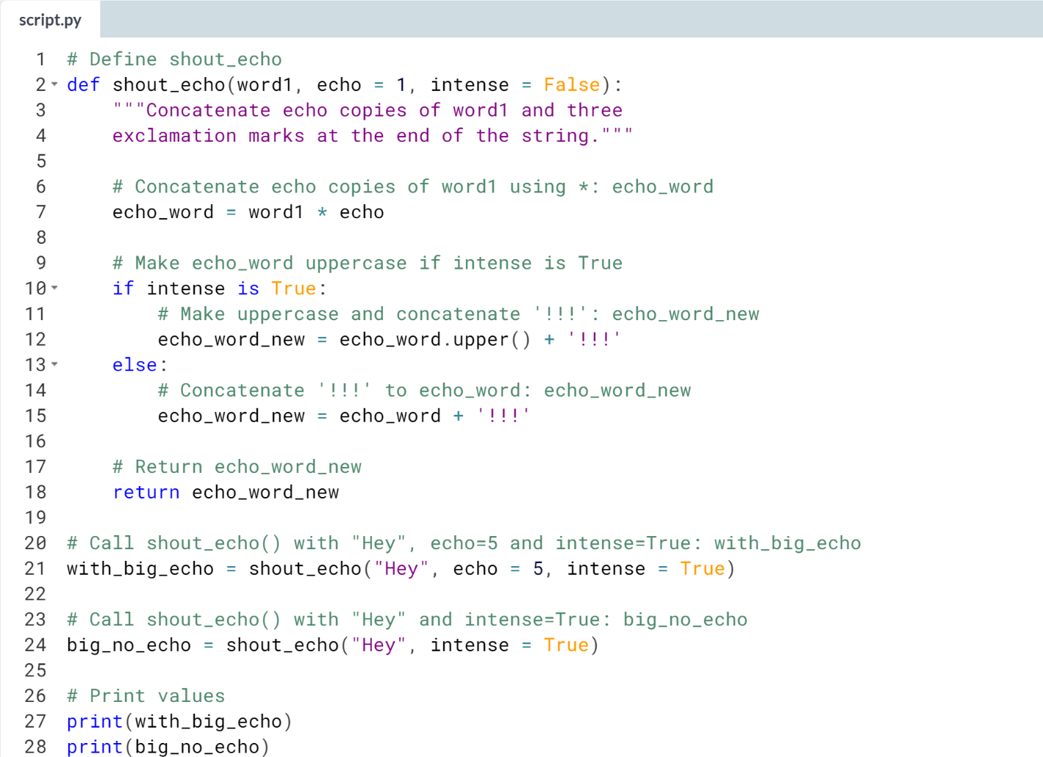  


# Functions with variable-length arguments (*args)

Flexible arguments enable you to pass a variable number of arguments to a function. In this exercise, you will practice defining a function that accepts a variable number of string arguments.

The function you will define is gibberish() which can accept a variable number of string values. Its return value is a single string composed of all the string arguments concatenated together in the order they were passed to the function call. You will call the function with a single string argument and see how the output changes with another call using more than one string argument. Recall from the previous video that, within the function definition, args is a tuple.

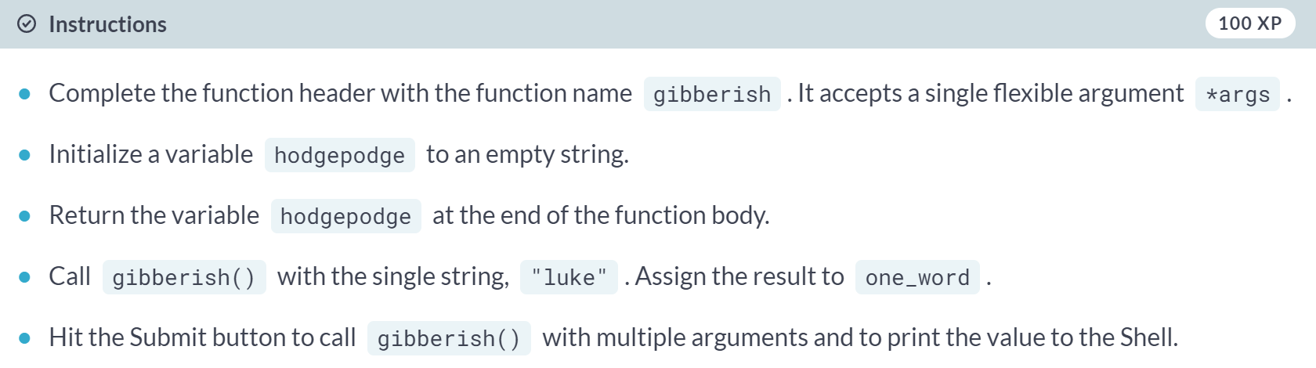  
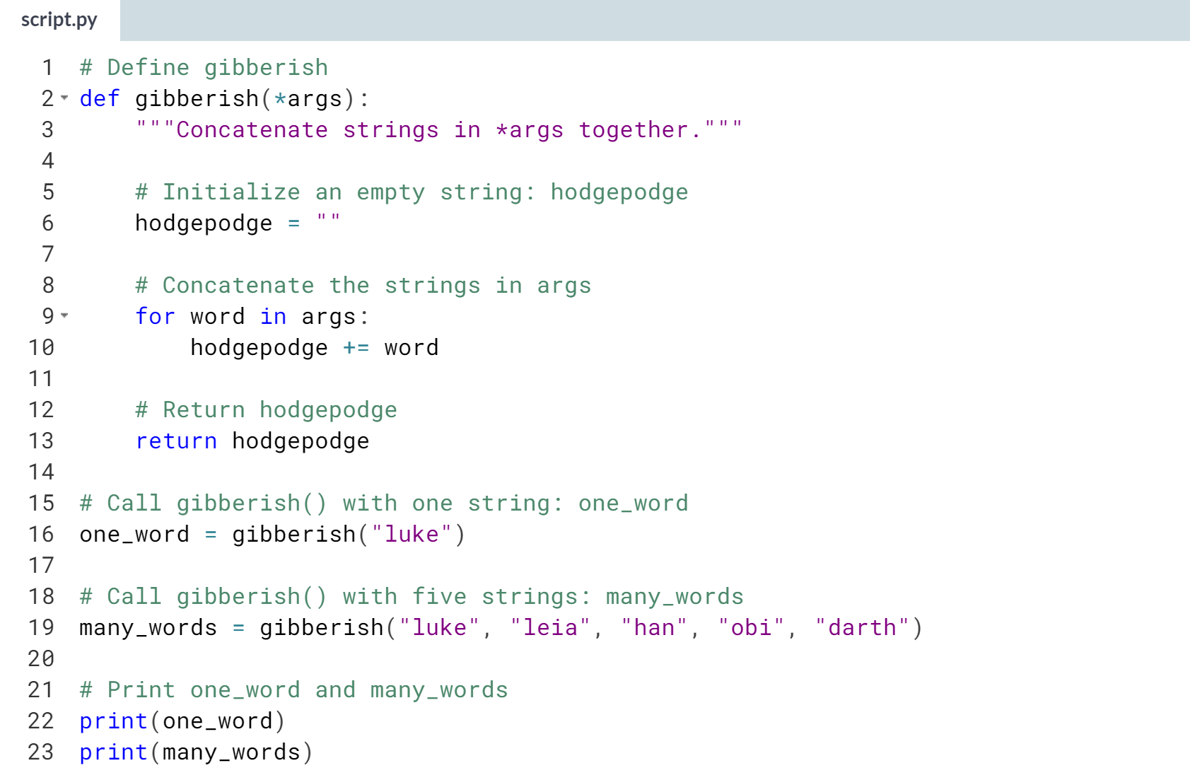  
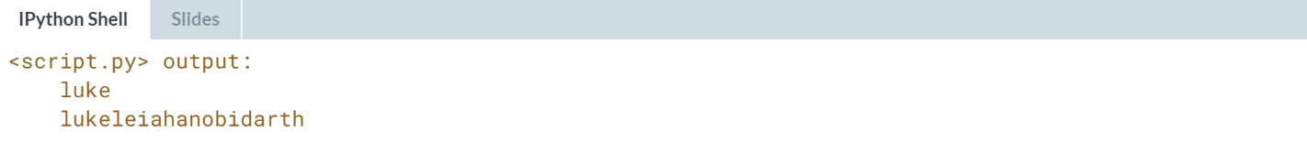

# Functions with variable-length keyword arguments (**kwargs)

Let's push further on what you've learned about flexible arguments - you've used *args, you're now going to use **kwargs! What makes **kwargs different is that it allows you to pass a variable number of keyword arguments to functions. Recall from the previous lesson that, within the function definition, kwargs is a dictionary.

To understand this idea better, you're going to use **kwargs in this exercise to define a function that accepts a variable number of keyword arguments. The function simulates a simple status report system that prints out the status of a character in a movie.

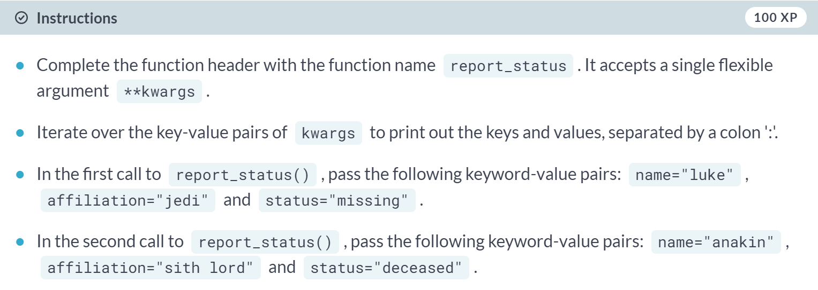  
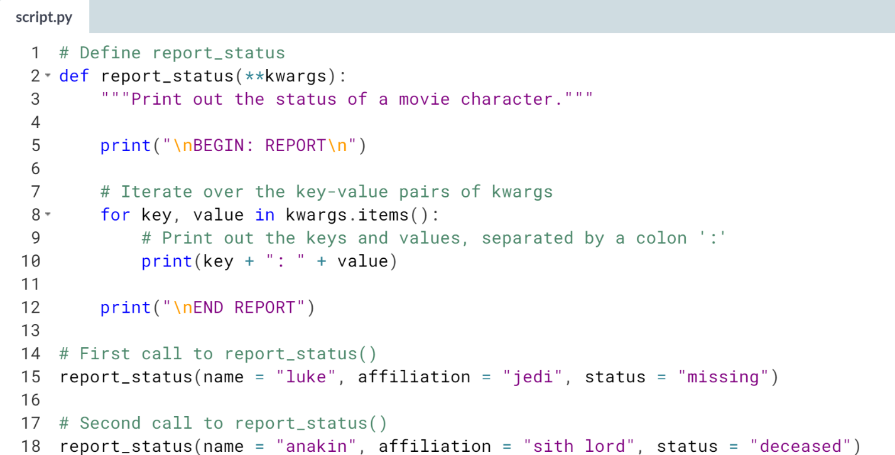  
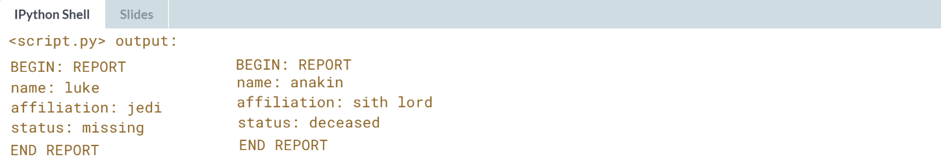



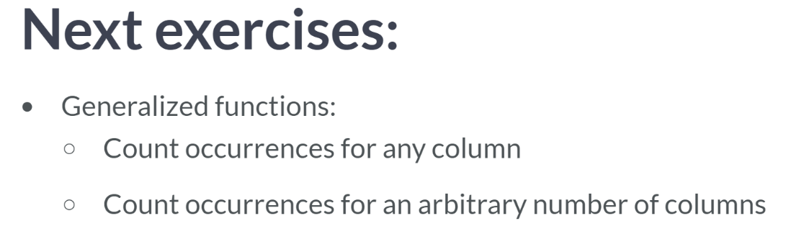  
In the following exercises, we will write a function that processes a DataFrame and returns a dictionary with counts of occurrences in any column at all!

By default, however, it will process a column called lang. This generalize the previous function you wrote in the previous exercise.

You will then generalize this further so that you can pass the function a DataFrame and any number of column names to perform the computation on an arbitrary number of columns.

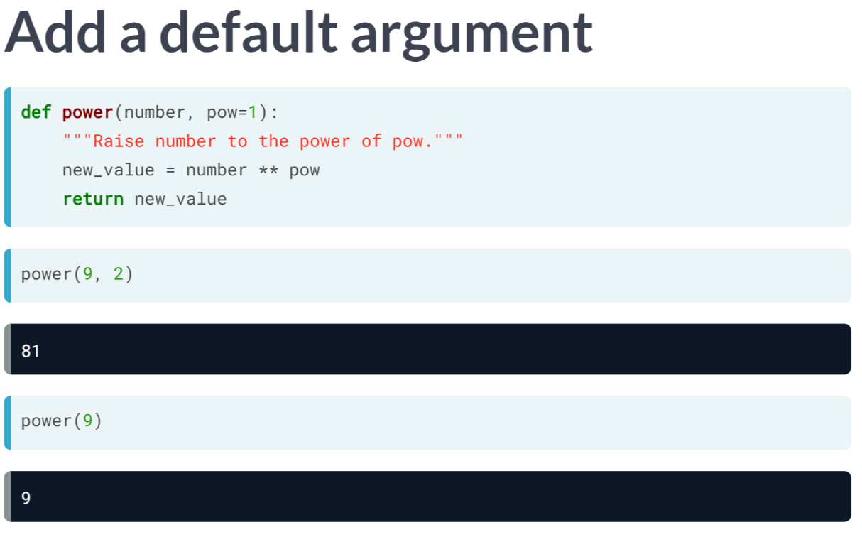  
Let's remind ourselves of the techniques necessary: recall that to define a function with a default argument, all that you need to do is provide that argument in the function header as you can see here.

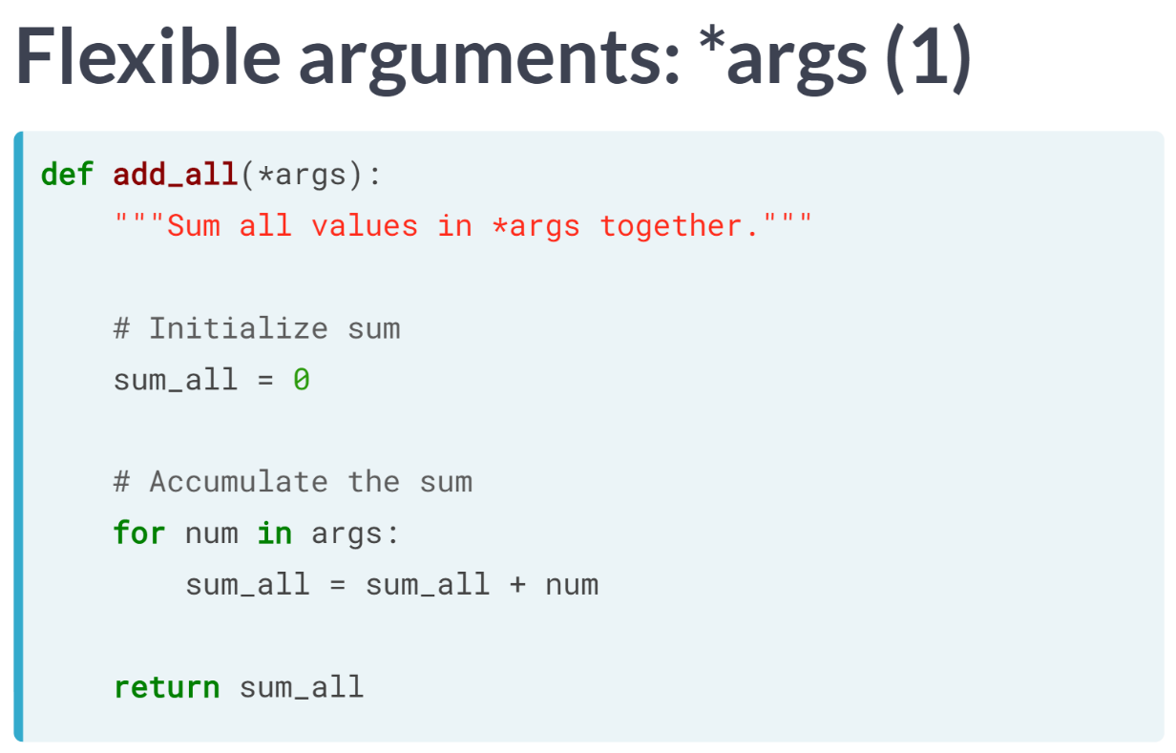  
Next up, to write a function that you can pass an arbitrary number of arguments to, that is, flexible arguments, we use the arguments *args* as here, and then we can loop over all elements of *args* in the function body. Now that we've had that quick refresher, let's write some more functions.

# Bringing it all together (1)

Recall the Bringing it all together exercise in the previous chapter where you did a simple Twitter analysis by developing a function that counts how many tweets are in certain languages. The output of your function was a dictionary that had the language as the keys and the counts of tweets in that language as the value.

In this exercise, we will generalize the Twitter language analysis that you did in the previous chapter. You will do that by including a **default argument** that takes a column name.

For your convenience, pandas has been imported as pd and the 'tweets.csv' file has been imported into the DataFrame tweets_df. Parts of the code from your previous work are also provided.

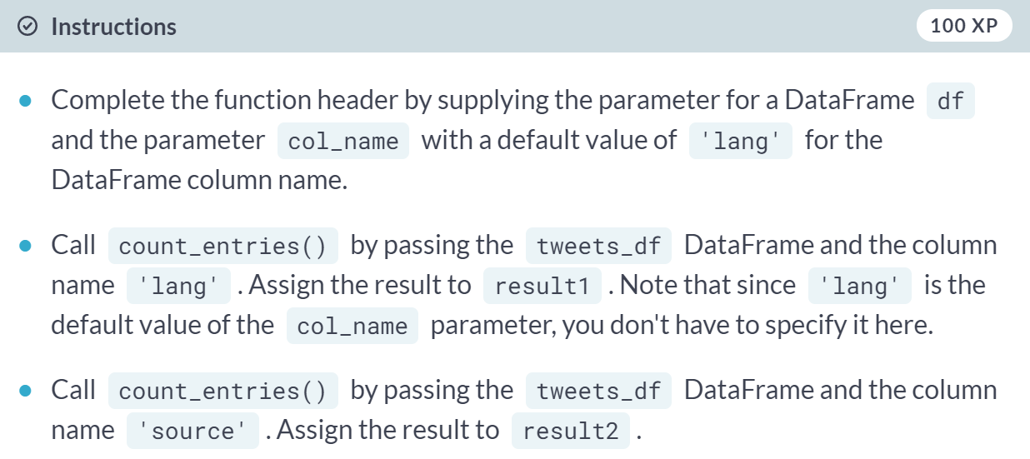

(Code on the next page)

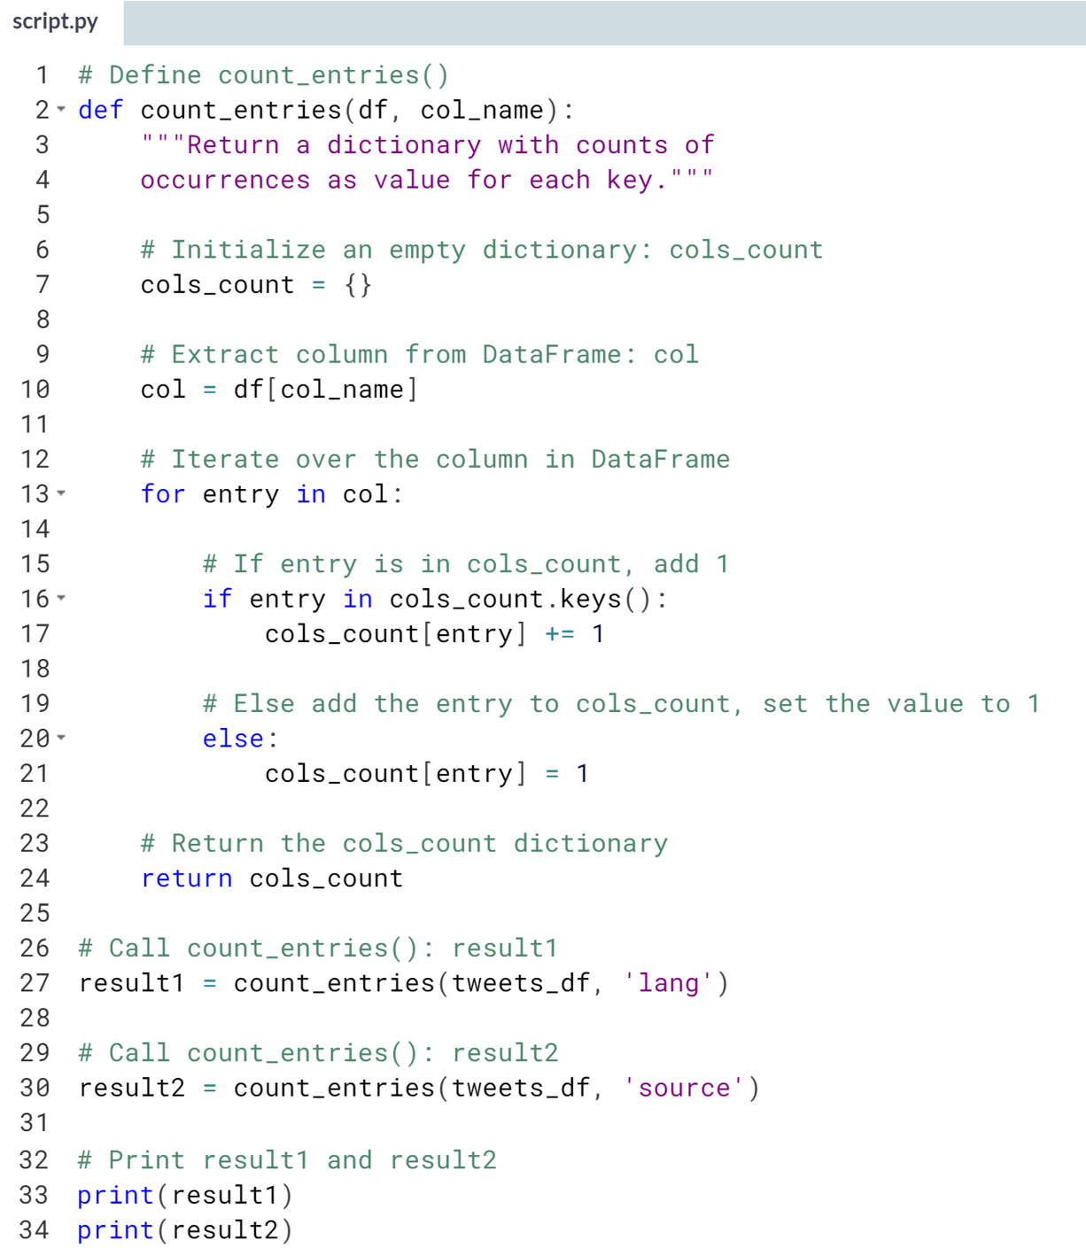  
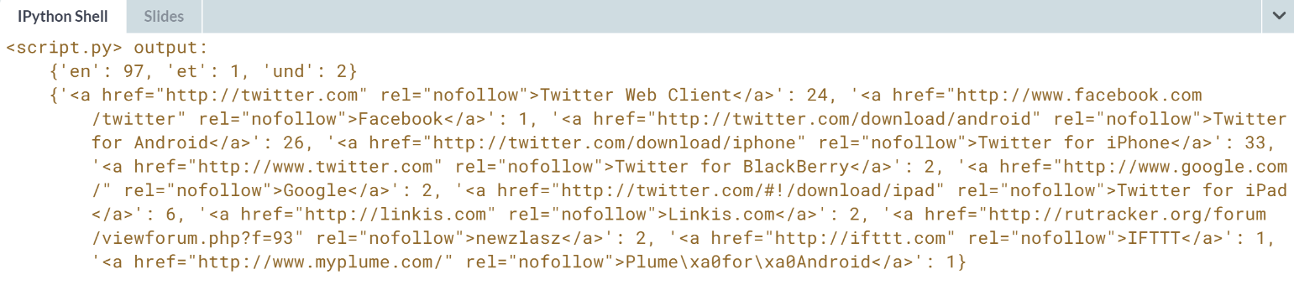

# Bringing it all together (2)

Wow, you've just generalized your Twitter language analysis that you did in the previous chapter to include a default argument for the column name. You're now going to generalize this function one step further by allowing the user to pass it a flexible argument, that is, in this case, as many column names as the user would like!

Once again, for your convenience, pandas has been imported as pd and the 'tweets.csv' file has been imported into the DataFrame tweets_df. Parts of the code from your previous work are also provided.

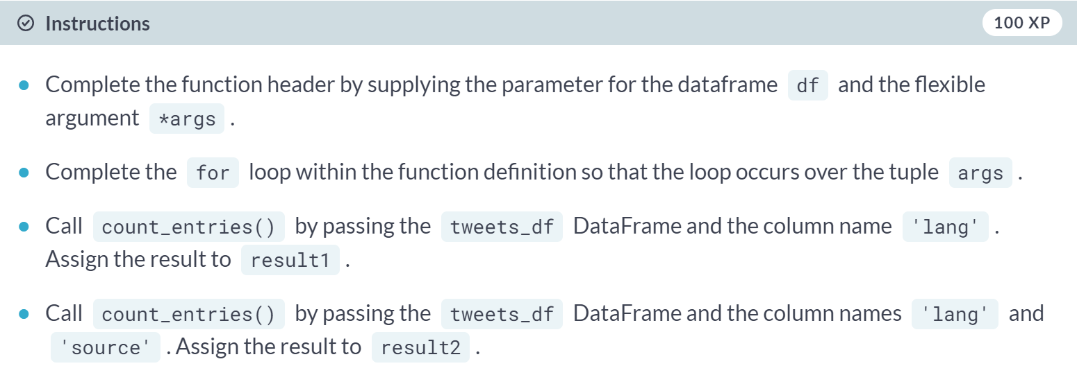

(Code on the next page)

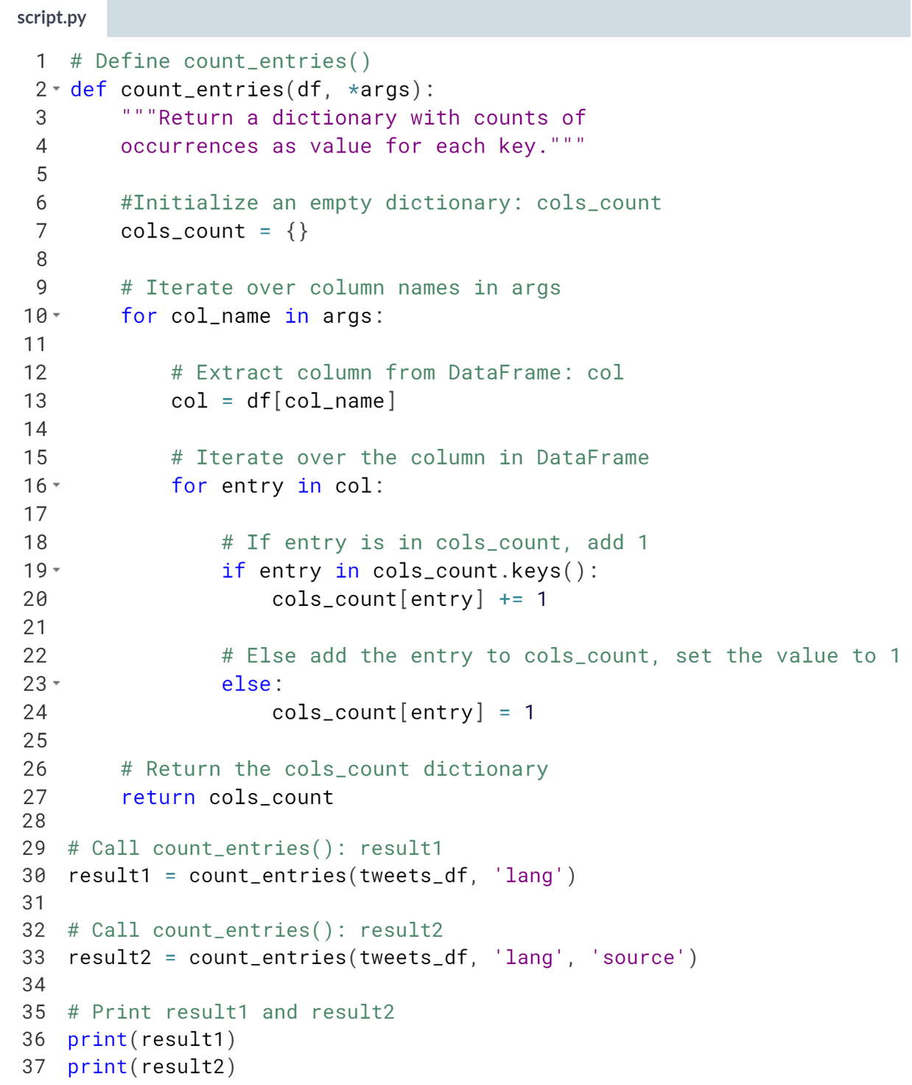  
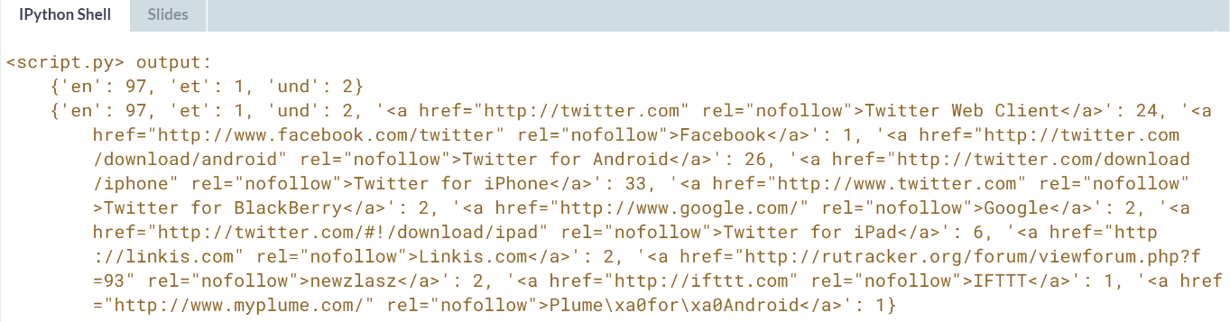

**3. Lambda functions and error-handling**

Learn about lambda functions, which allow you to write functions quickly and on the fly. You'll also practice handling errors in your functions, which is an essential skill. Then, apply your new skills to answer data science questions.



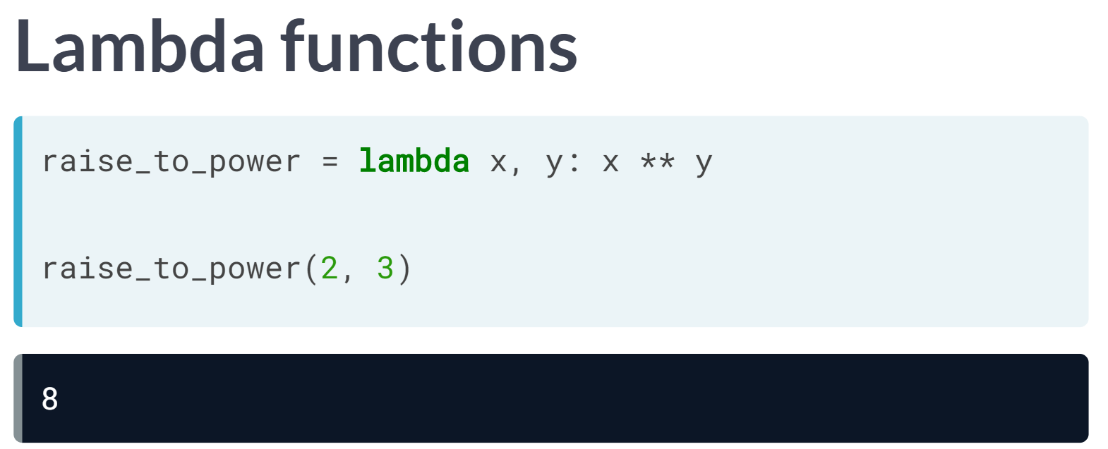  
There is a quicker way to write functions on the fly and these are called **lambda functions** because you use the keyword *lambda*.

Here we rewrite our function *raise_to_power* as a lambda function. To do so, after the keyword lambda, we specify the names of the arguments; then we use a colon followed by the expression that specifies what we wish the function to return.

Lambda functions allow us to write functions in a quick and potentially dirty way so it is not advisable to use them all the time, but there are situations when they can come in very handy.

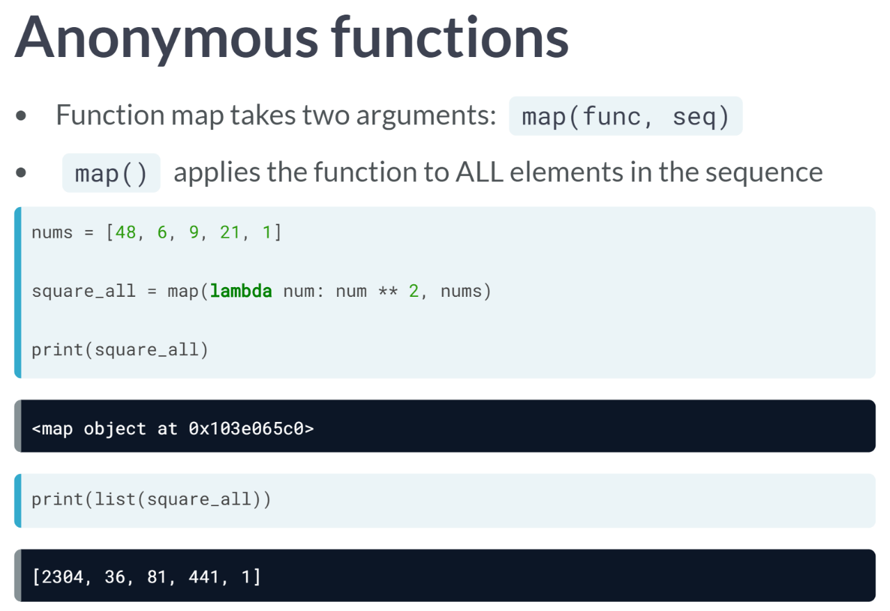

For example, check out the map function, which takes two arguments, a function, and a sequence such as a list and applies the function over all elements of the sequence.

We can pass the lambda functions to map without even naming them and in this case we refer to them as anonymous function.

In this example, we use ***map()*** on a lambda function that squares all elements of a list and we'll store the result in *square_all*.

Printing *square_all* reveals that it is actually a map object so to see what it contains we use the function list to turn it into a list and print the results to the shell.

As expected, it is a list containing the squares of the elements in the original list.

# Pop quiz on lambda functions

In this exercise, you will practice writing a simple lambda function and calling this function. Recall what you know about lambda functions and answer the following questions:

* How would you write a lambda function add_bangs that adds three exclamation points '!!!' to the end of a string a?
* How would you call add_bangs with the argument 'hello'?

You may use the IPython shell to test your code.

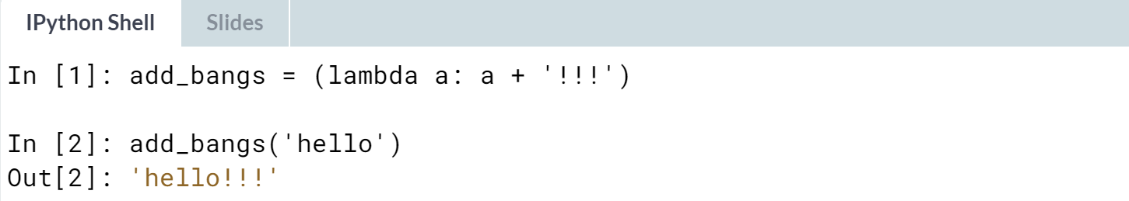

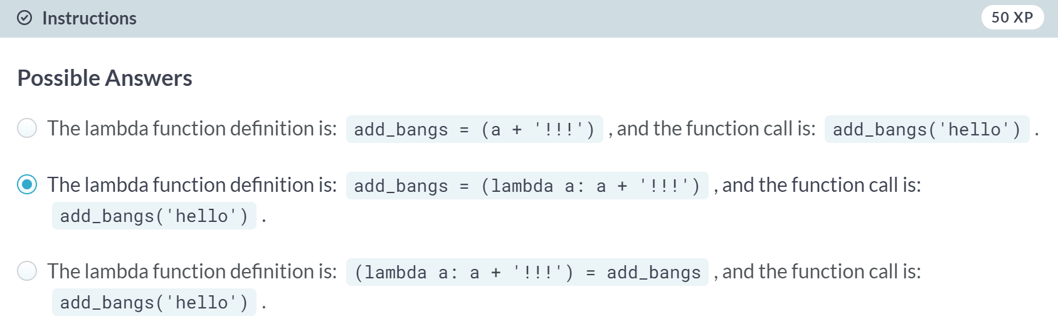

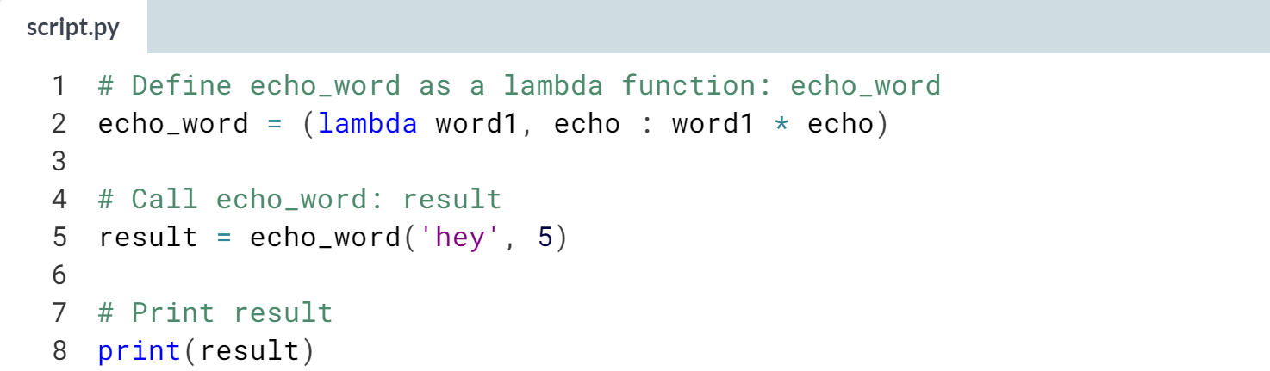

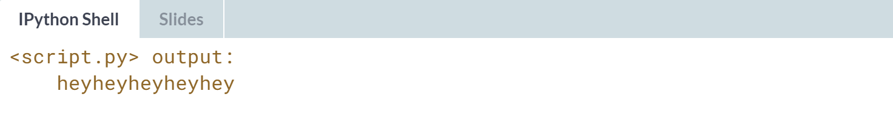

# Writing a lambda function that you already know

Some function definitions are simple enough that they can be converted to a lambda function. By doing this, you write less lines of code, which is pretty awesome and will come in handy, especially when you're writing and maintaining big programs.

In this exercise, you will use what you know about lambda functions to convert a function that does a simple task into a lambda function. Take a look at this function definition:

def echo_word(word1, echo):

"""Concatenate echo copies of word1."""

words = word1 * echo

return words

The function echo_word takes 2 parameters: a string value, word1 and an integer value, echo. It returns a string that is a concatenation of echo copies of word1. Your task is to convert this simple function into a lambda function.

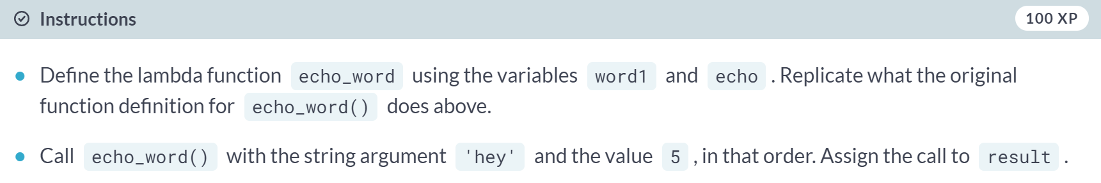  
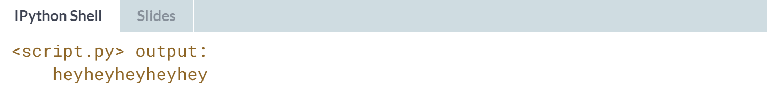

# Map() and lambda functions

So far, you've used lambda functions to write short, simple functions as well as to redefine functions with simple functionality. The best use case for lambda functions, however, are for when you want these simple functionalities to be anonymously embedded within larger expressions.

What that means is that the functionality is not stored in the environment, unlike a function defined with def. To understand this idea better, you will use a lambda function in the context of the map() function.

Recall from the video that map() applies a function over an object, such as a list. Here, you can use lambda functions to define the function that map() will use to process the object. For example:

nums = [2, 4, 6, 8, 10]

result = map(lambda a: a ** 2, nums)

You can see here that a lambda function, which raises a value a to the power of 2, is passed to map() alongside a list of numbers, nums. The map object that results from the call to map() is stored in result.

You will now practice the use of lambda functions with map(). For this exercise, you will map the functionality of the add_bangs() function you defined in previous exercises over a list of strings.

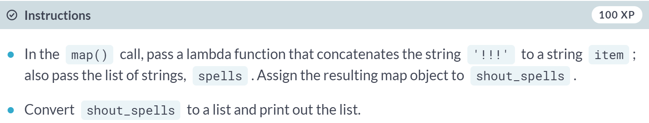

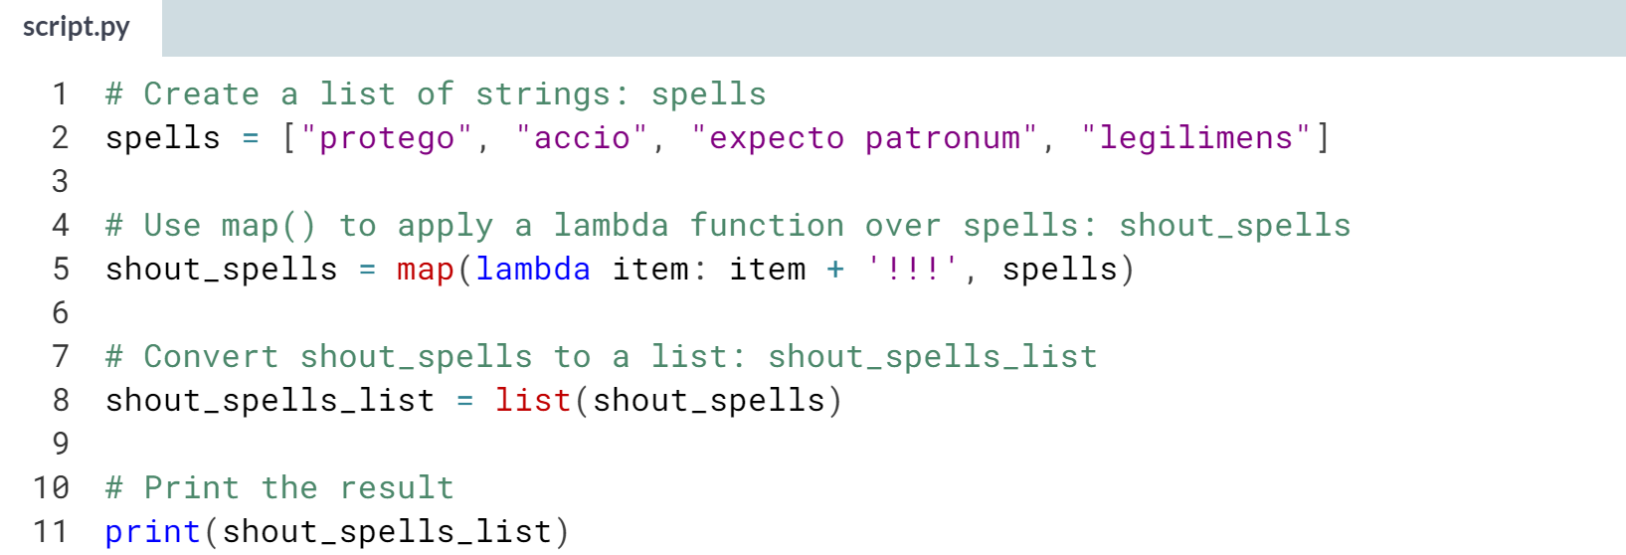  
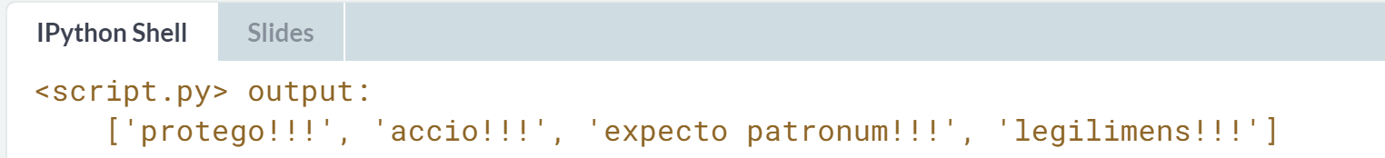

# Filter() and lambda functions

In the previous exercise, you used lambda functions to anonymously embed an operation within map(). You will practice this again in this exercise by using a lambda function with filter(), which may be new to you! The function filter() offers a way to filter out elements from a list that don't satisfy certain criteria.

Your goal in this exercise is to use filter() to create, from an input list of strings, a new list that contains only strings that have more than 6 characters.

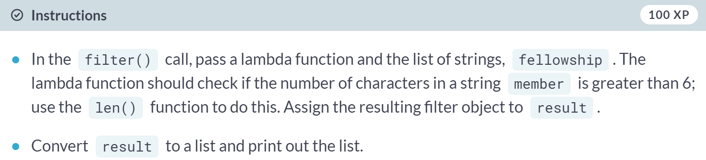

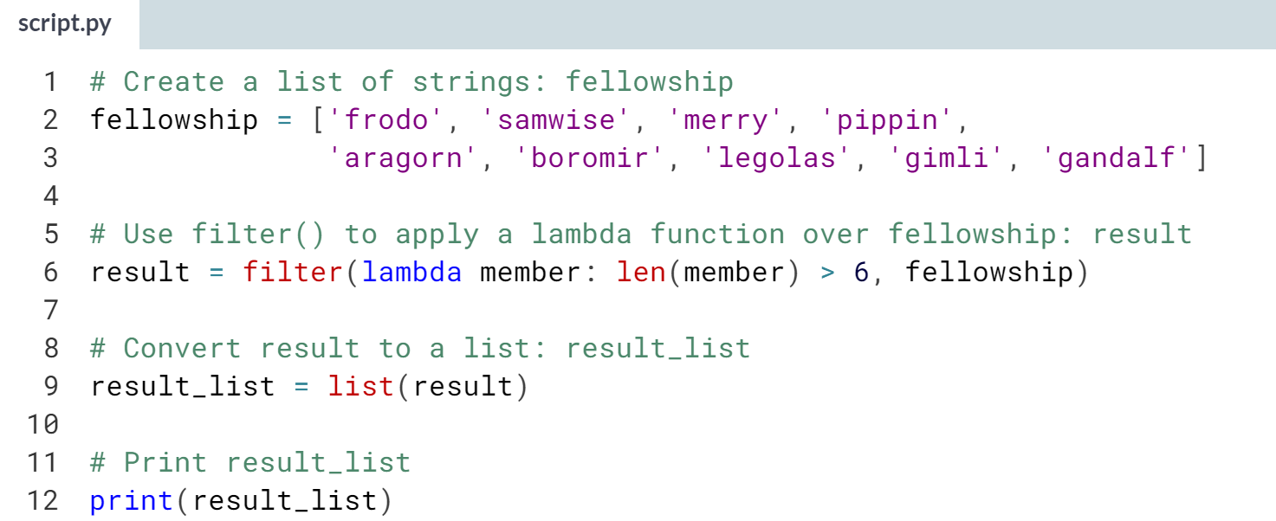

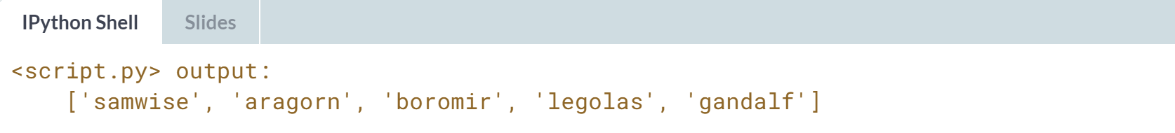

# Reduce() and lambda functions

You're getting very good at using lambda functions! Here's one more function to add to your repertoire of skills. The reduce() function is useful for performing some computation on a list and, unlike map() and filter(), returns a single value as a result. To use reduce(), you must import it from the functools module.

Remember gibberish() from a few exercises back?

# Define gibberish

def gibberish(*args):

"""Concatenate strings in *args together."""

hodgepodge = ' '

for word in args:

hodgepodge += word

return hodgepodge

gibberish() simply takes a list of strings as an argument and returns, as a single-value result, the concatenation of all of these strings. In this exercise, you will replicate this functionality by using reduce() and a lambda function that concatenates strings together.

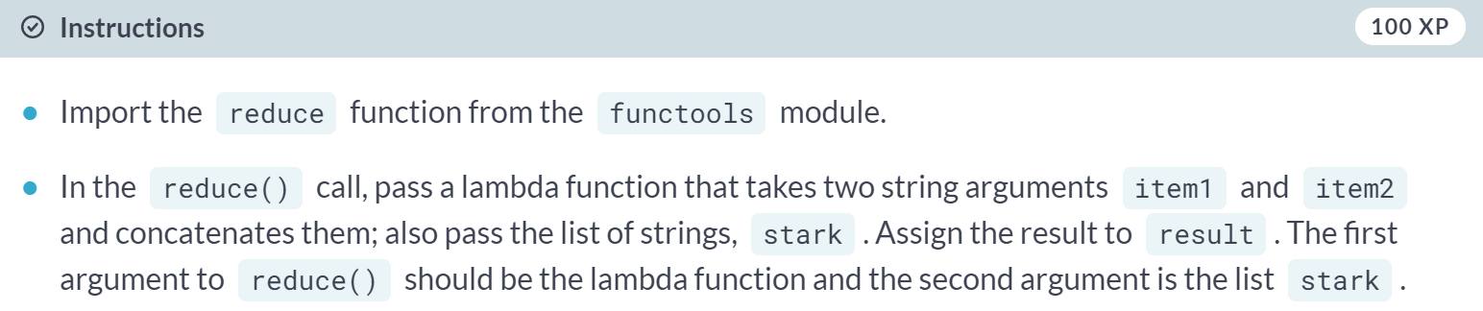  
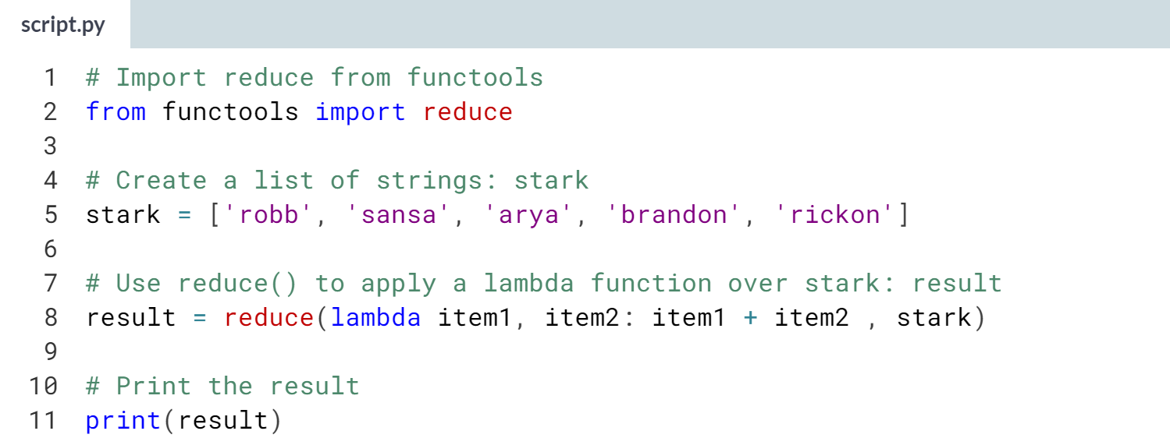  
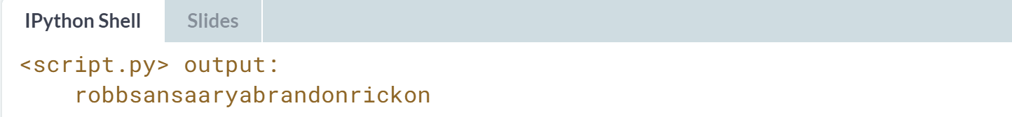



When you use a function incorrectly, it should throw you an error.

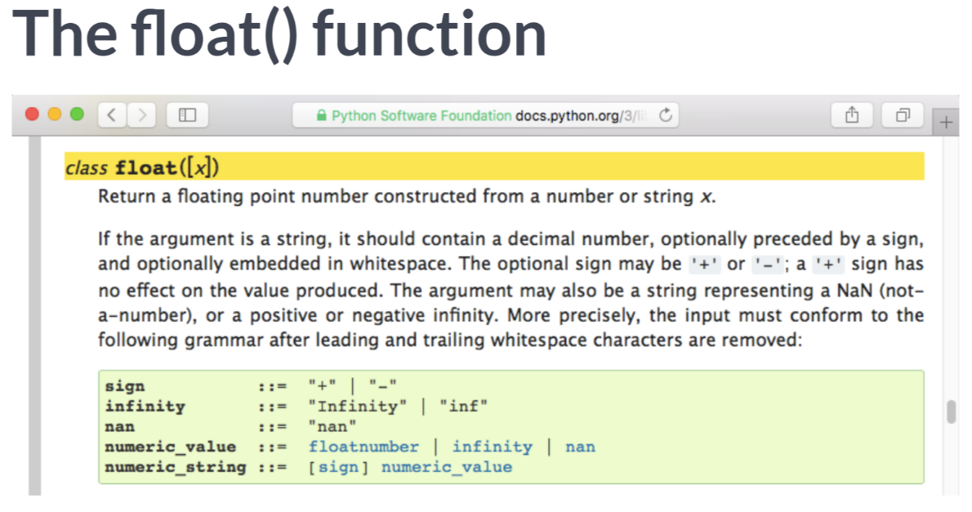  
For example, check out the function float that returns a floating point from a number or string, under the condition that the string corresponds to a number. When I pass the function float an integer, the corresponding float is returned.

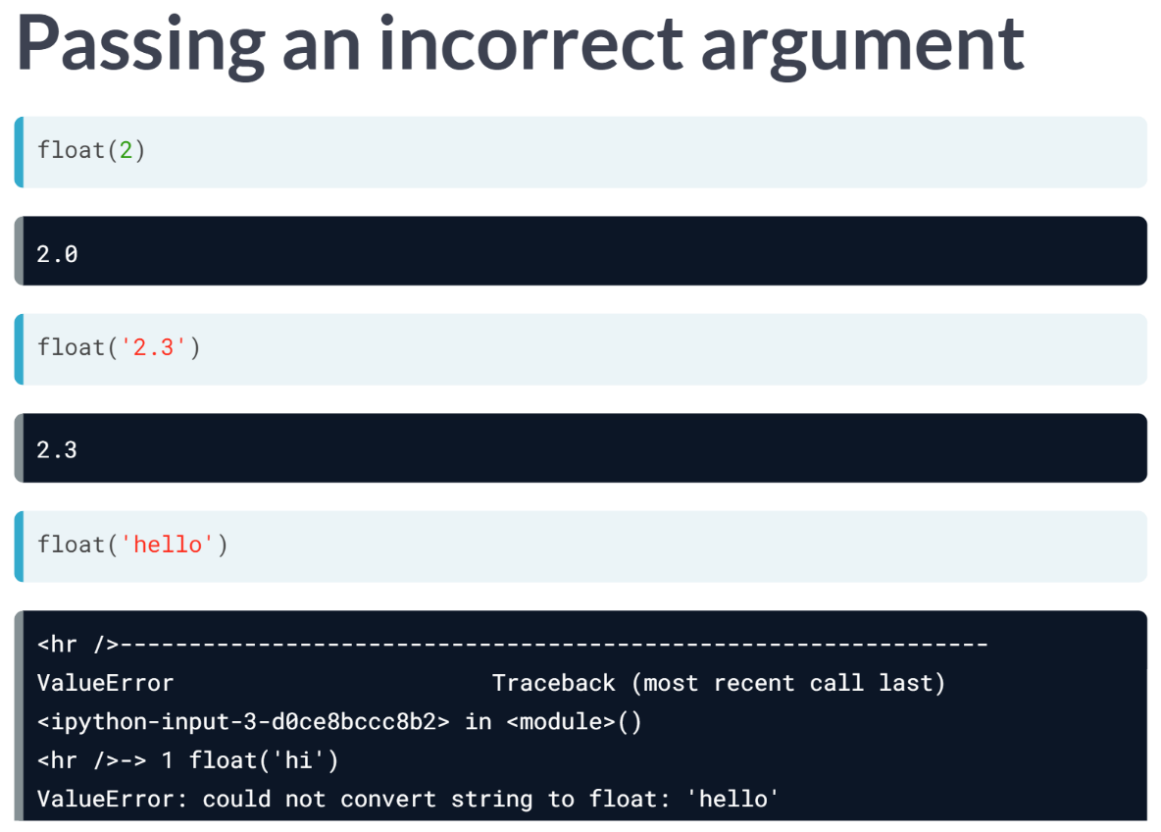  
However, if I pass it the string 'hello', Python will throw an error telling me that it couldn't convert the string to a float. In this case, it threw a ValueError and there are many types of errors.

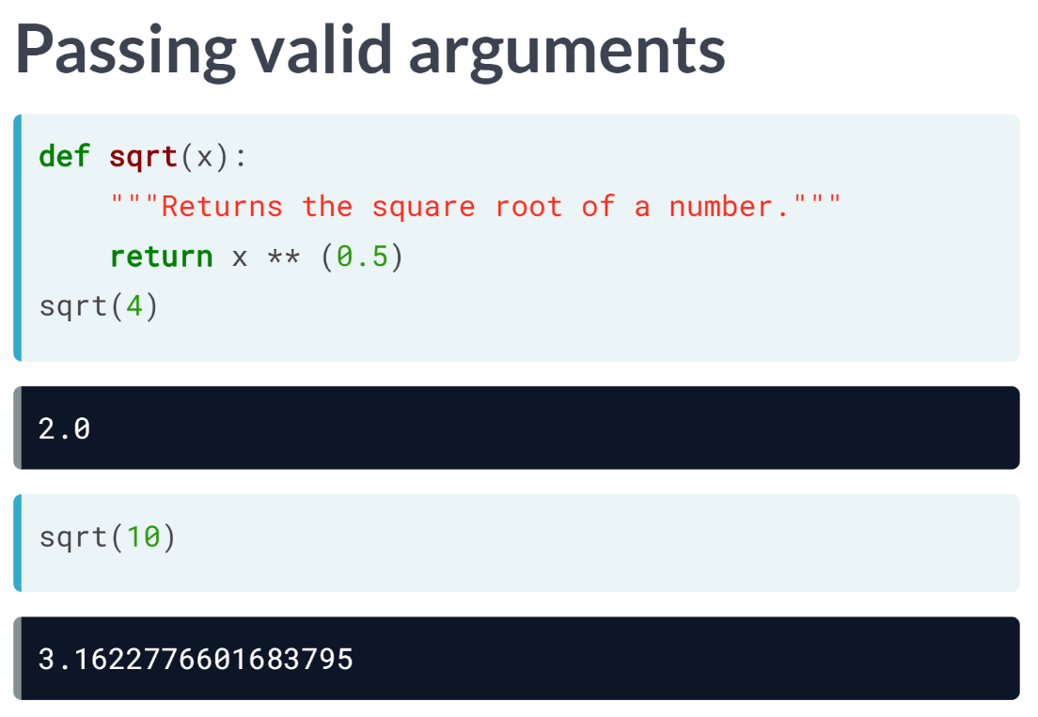  
When we write our own function, as we have been doing, we may wish to catch specific problems and write specific error messages.

Let's check out this user-defined function that computes the square root of a number. It behaves as expected with integers.

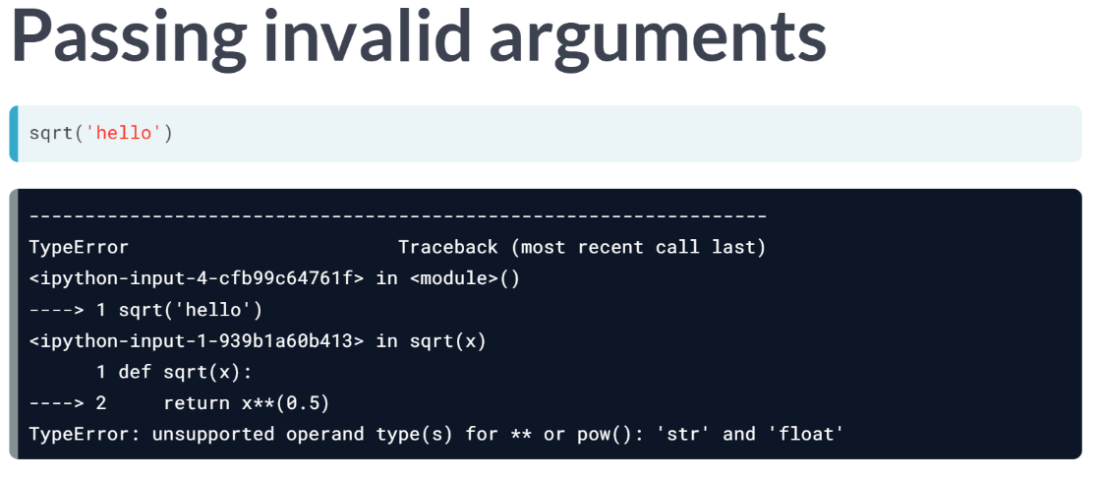  
What happens if we pass it a string such as 'hello'? Then it throws an error corresponding to a line of code within the function definition.

This error says it was some sort of TypeError, but the message may not be particularly useful to a user of our function, so we should endeavor to provide useful error messages for the function we write.

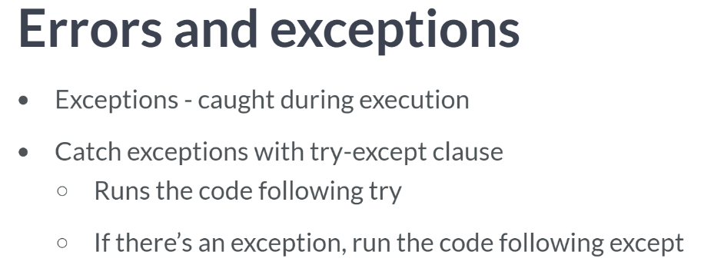

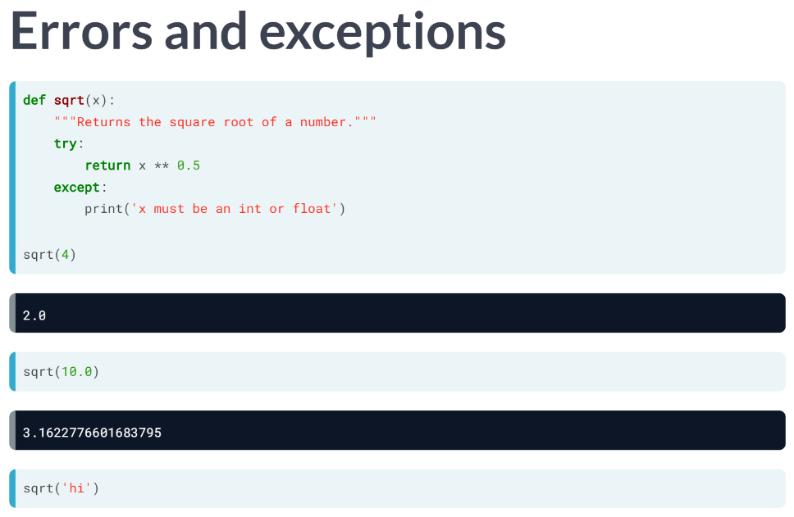  
Let's now rewrite our square root function, but this time, catch any exceptions raised. So here, we try to execute x to the power of 0.5; using except, in the case of an exception, we print 'x must be an int or float'. Now we see that the resulting function behaves well for ints and floats and also prints out what we wanted it to for a string.  
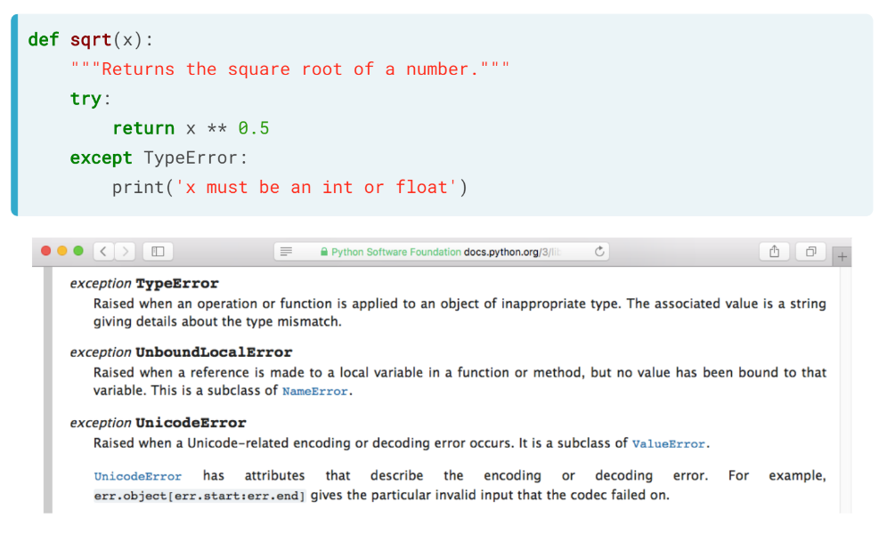  
We may also wish it to only catch TypeErrors and let other errors pass through, in which case we would use except TypeError as you can see here. There are many other types of exceptions that can be caught, and you can have a look at them in the Python documentation available online.

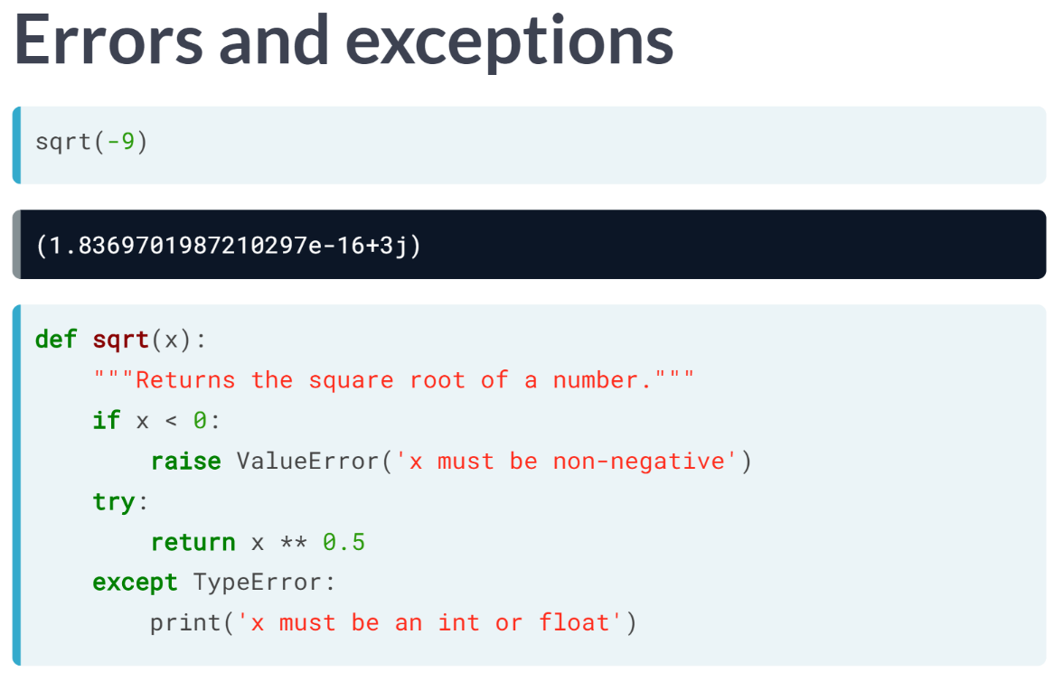  
More often than not, instead of merely printing an error message, we will want to actually raise an error by using the keyword raise.

For example, our square root function does something we may not desire when applied to negative numbers.

It actually returns a complex number, which we may not want. In fact, let's say that we don't wish our function to work for negative numbers.

Then, using an if clause, we can raise a ValueError for cases in which the user passes the function a negative number.

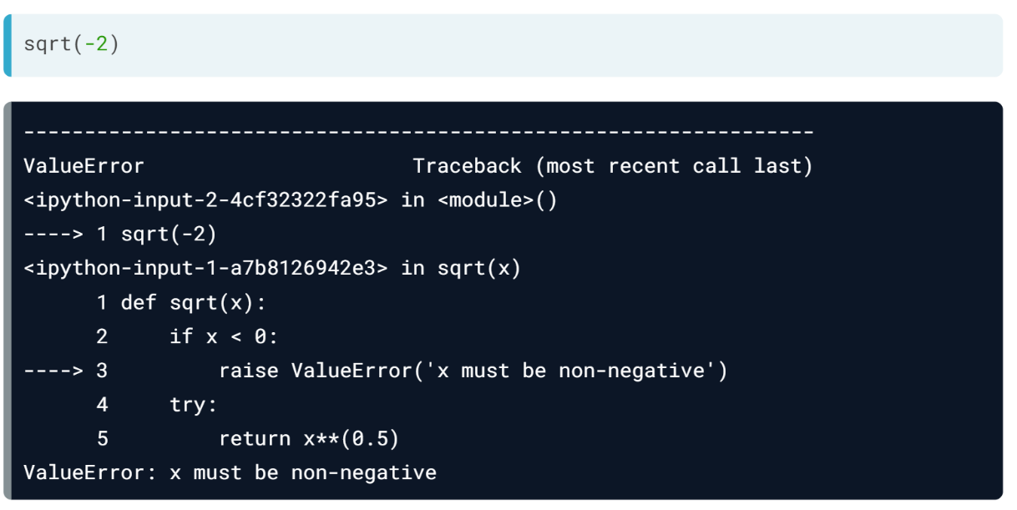  
If we pass our new function a negative number, see it returns the prescribed ValueError!

# Pop quiz about errors

In the video, Hugo talked about how errors happen when functions are supplied arguments that they are unable to work with. In this exercise, you will identify which function call raises an error and what type of error is raised.

Take a look at the following function calls to len():

len('There is a beast in every man, and it stirs when you put a sword in his hand.')

len(['robb', 'sansa', 'arya', 'eddard', 'jon'])

len(525600)

len(('jaime', 'cersei', 'tywin', 'tyrion', 'joffrey'))

Which of the function calls raises an error and what type of error is raised?

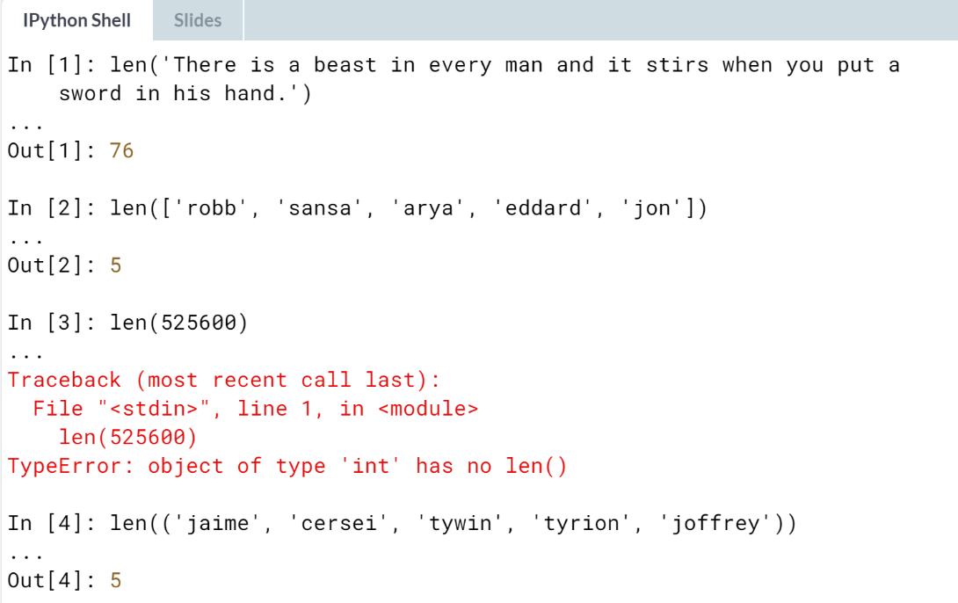  
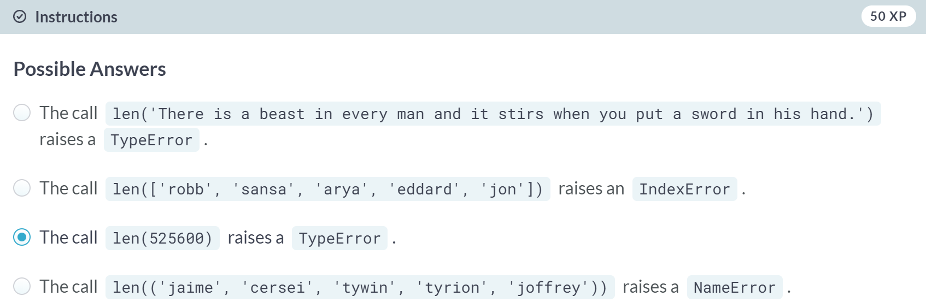

# Error handling with try-except

A good practice in writing your own functions is also anticipating the ways in which other people (or yourself, if you accidentally misuse your own function) might use the function you defined.

As in the previous exercise, you saw that the len() function is able to handle input arguments such as strings, lists, and tuples, but not int type ones and raises an appropriate error and error message when it encounters invalid input arguments. One way of doing this is through exception handling with the try-except block.

In this exercise, you will define a function as well as use a try-except block for handling cases when incorrect input arguments are passed to the function.

Recall the shout_echo() function you defined in previous exercises; parts of the function definition are provided in the sample code. Your goal is to complete the exception handling code in the function definition and provide an appropriate error message when raising an error.

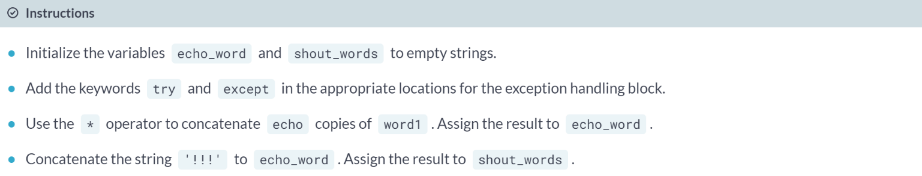

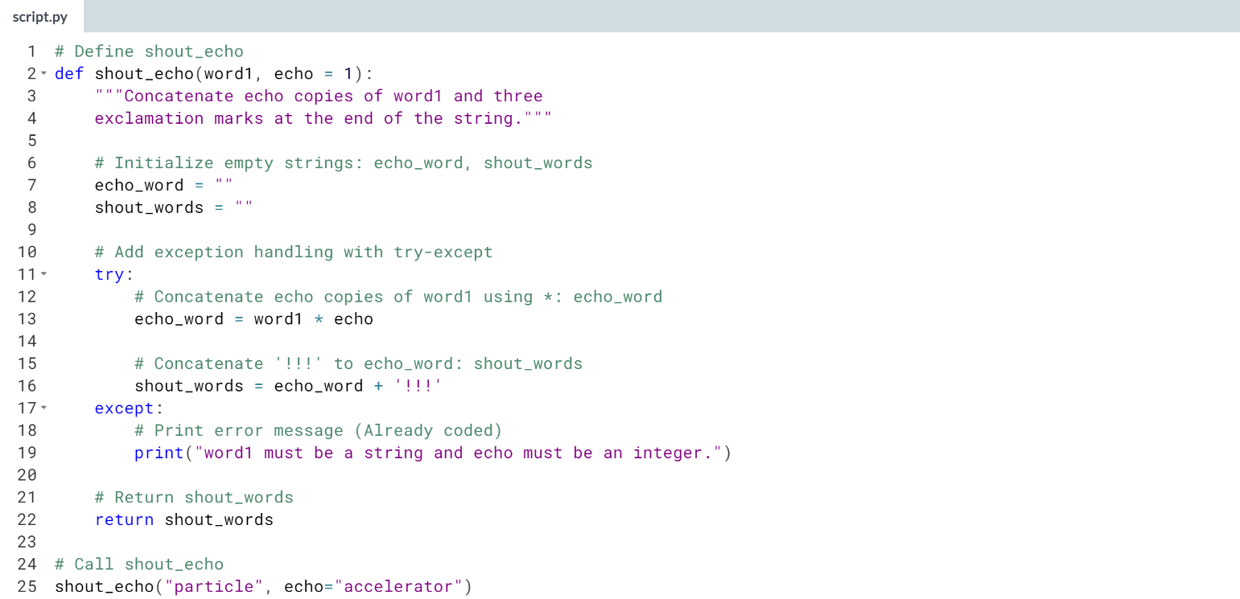  


# Error handling by raising an error

Another way to raise an error is by using raise. In this exercise, you will add a raise statement to the shout_echo() function you defined before to raise an error message when the value supplied by the user to the echo argument is less than 0.

The call to shout_echo() uses valid argument values. To test and see how the raise statement works, simply change the value for the echo argument to a negative value. Don't forget to change it back to valid values to move on to the next exercise!

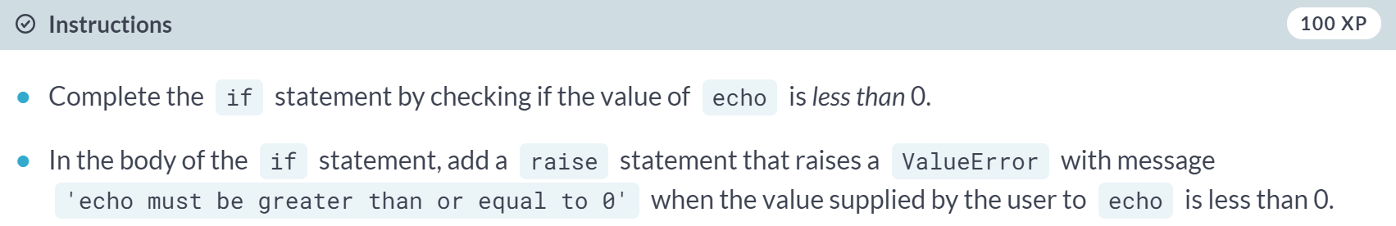  
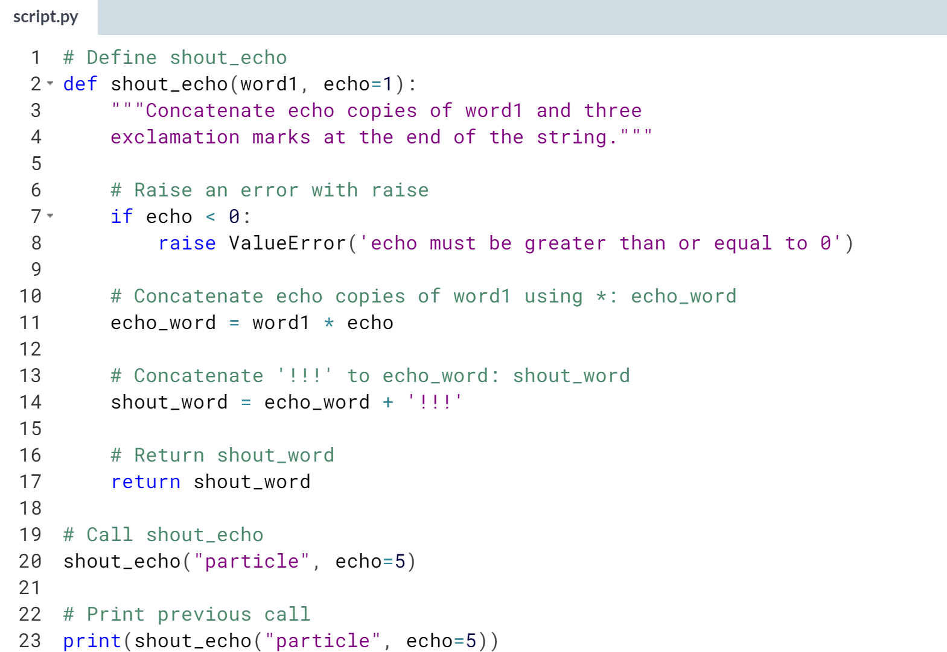  




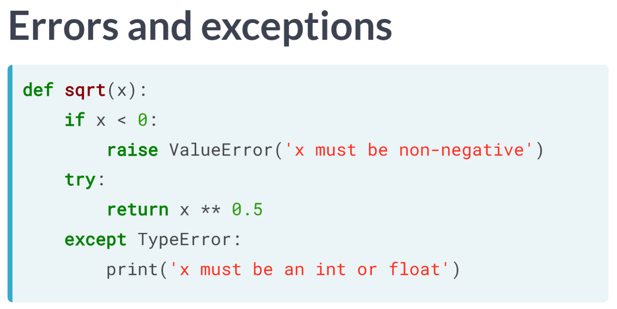  
Let's say that a user of your function passes your function the name of a column that isn't a column in the DataFrame that they pass it; you'll want to let them know.

In the following interactive exercises, you will write error messages using two methods that you have learned:

One, using the try-except syntax that you see here.

Two, explicitly raising errors using the keyword raise as in this example.

# Bringing it all together (1)

This is awesome! You have now learned how to write anonymous functions using lambda, how to pass lambda functions as arguments to other functions such as map(), filter(), and reduce(), as well as how to write errors and output custom error messages within your functions.

You will now put together these learnings to good use by working with a Twitter dataset. Before practicing your new error handling skills, in this exercise, you will write a lambda function and use filter() to select retweets, that is, tweets that begin with the string 'RT'.

To help you accomplish this, the Twitter data has been imported into the DataFrame, tweets_df. Go for it!

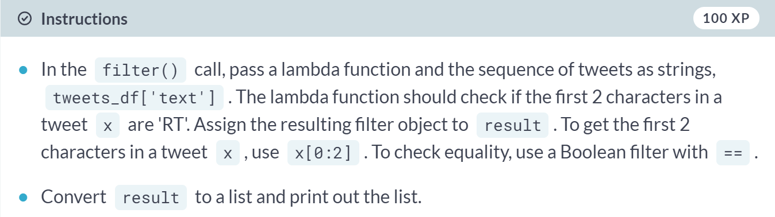  
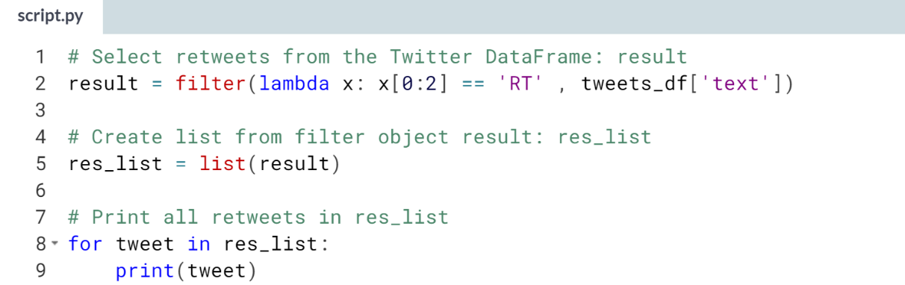  
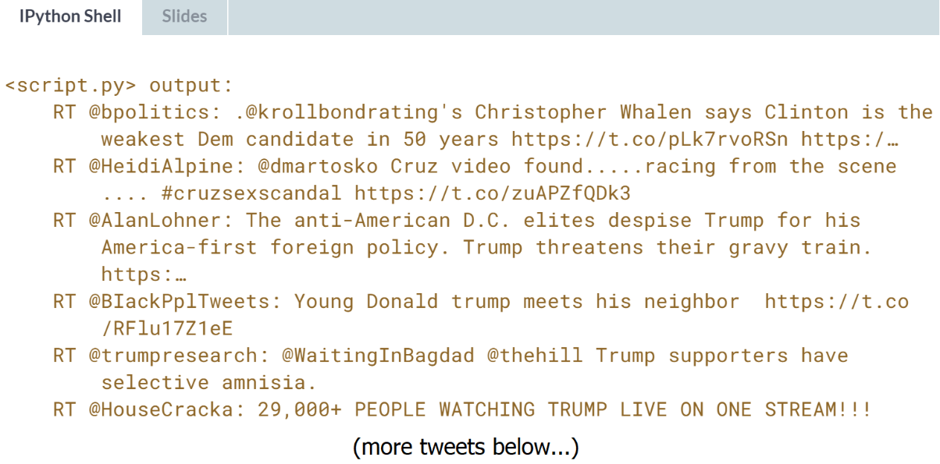

# Bringing it all together (2)

Sometimes, we make mistakes when calling functions - even ones you made yourself. But don't fret! In this exercise, you will improve on your previous work with the count_entries() function in the last chapter by adding a try-except block to it. This will allow your function to provide a helpful message when the user calls your count_entries() function but provides a column name that isn't in the DataFrame.

Once again, for your convenience, pandas has been imported as pd and the 'tweets.csv' file has been imported into the DataFrame tweets_df. Parts of the code from your previous work are also provided.

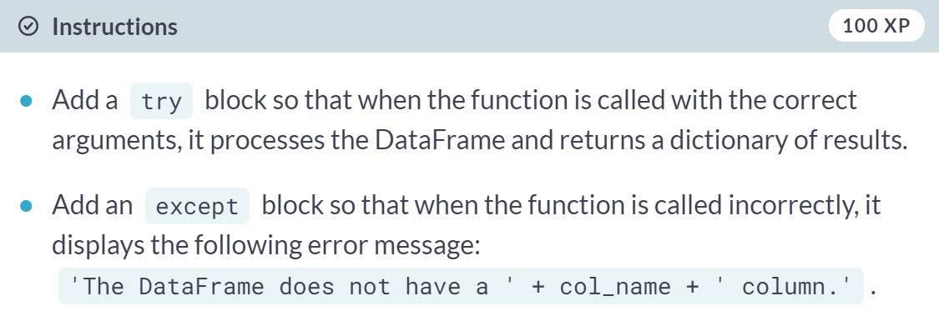

(Code on the next page)

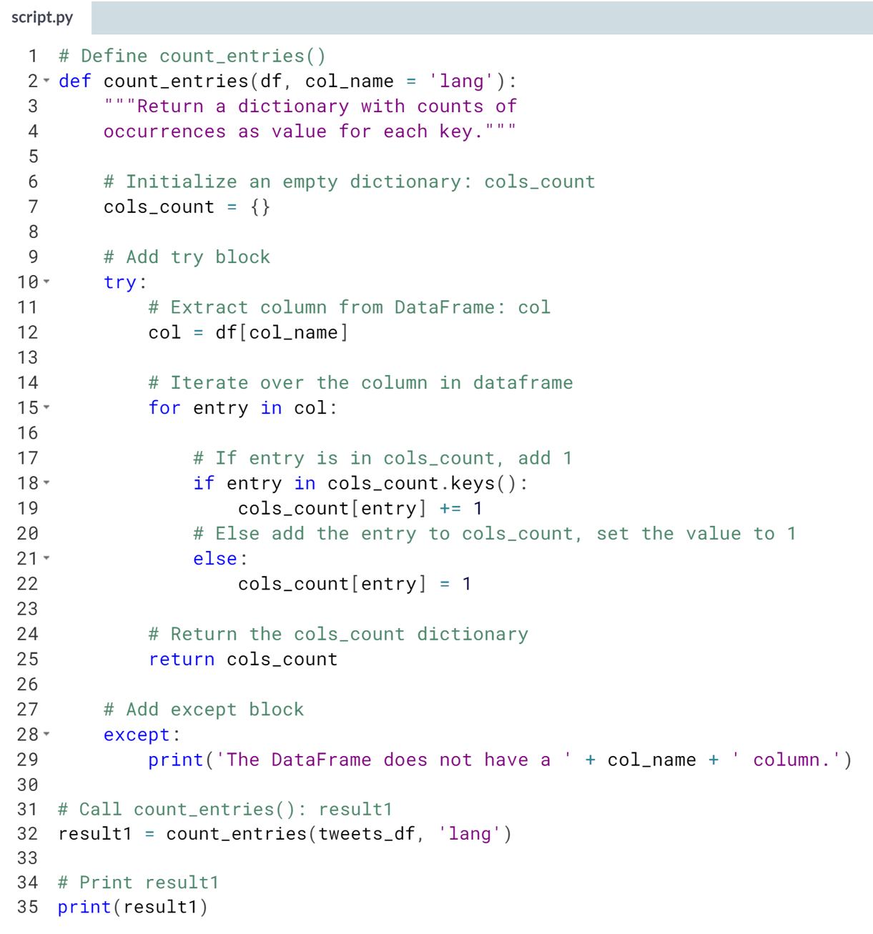  
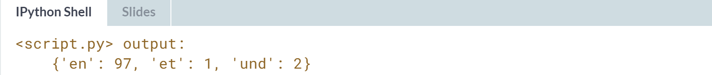

# Bringing it all together (3)

In the previous exercise, you built on your function count_entries() to add a try-except block. This was so that users would get helpful messages when calling your count_entries() function and providing a column name that isn't in the DataFrame. In this exercise, you'll instead raise a ValueError in the case that the user provides a column name that isn't in the DataFrame.

Once again, for your convenience, pandas has been imported as pd and the 'tweets.csv' file has been imported into the DataFrame tweets_df. Parts of the code from your previous work are also provided.

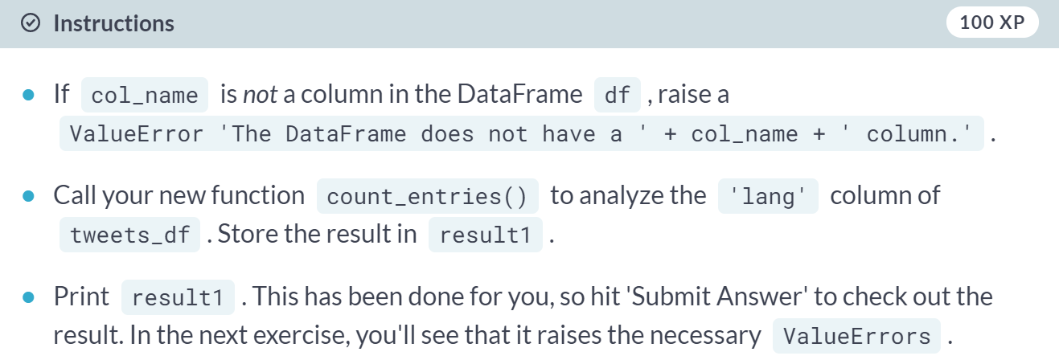

(Code on the next page)

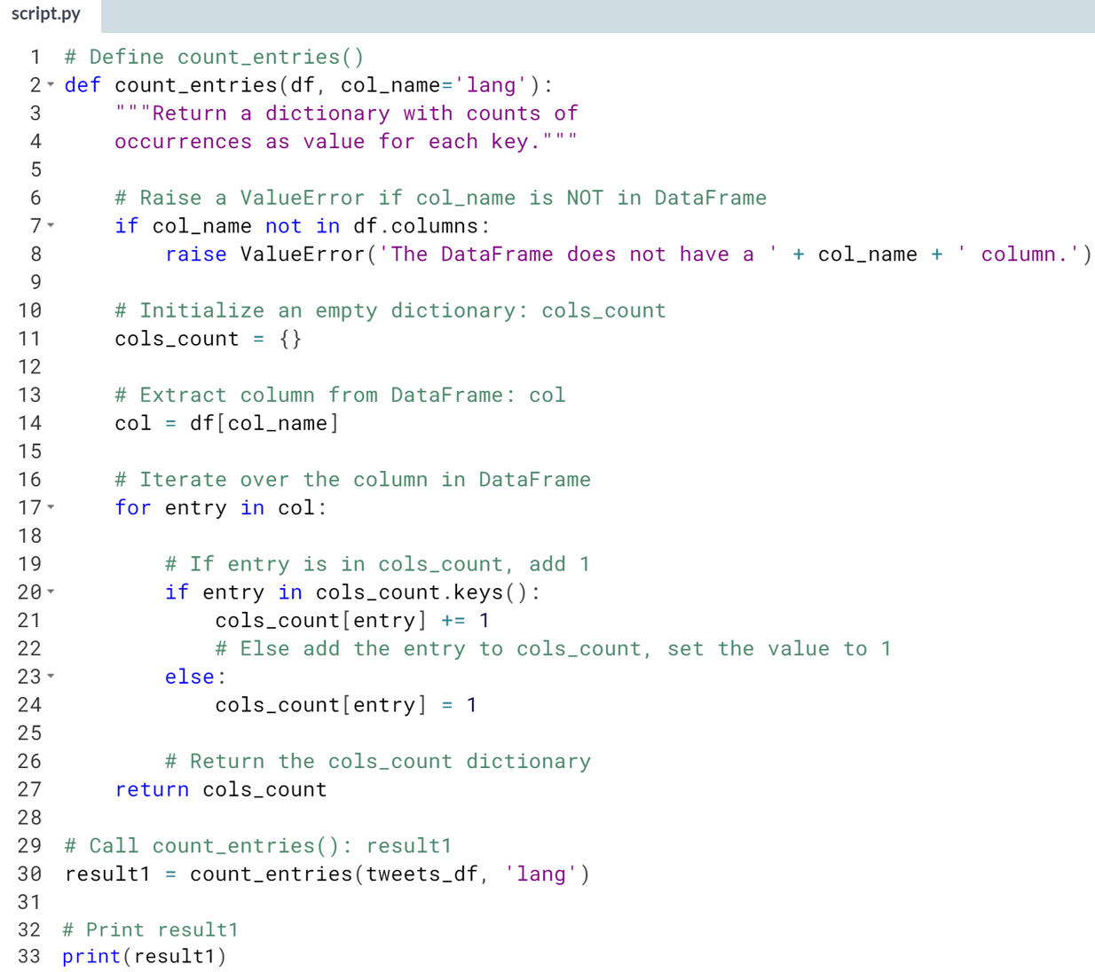  


# Bringing it all together: testing your error handling skills

You have just written error handling into your count_entries() function so that, when the user passes the function a column (as 2nd argument) NOT contained in the DataFrame (1st argument), a ValueError is thrown.

You're now going to play with this function: it is loaded into pre-exercise code, as is the DataFrame tweets_df. Try calling count_entries(tweets_df, 'lang') to confirm that the function behaves as it should. Then call count_entries(tweets_df, 'lang1'): what is the last line of the output?

